Results
Design
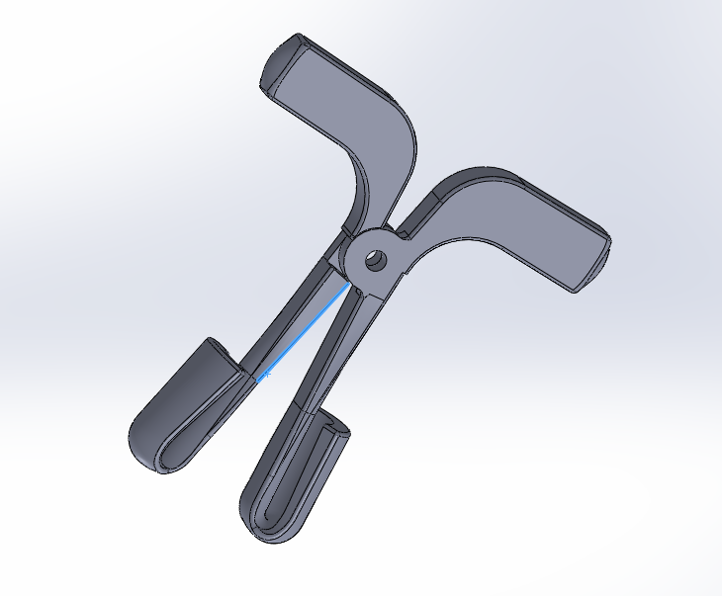
Figure 1: Shows a SolidWorks drawing of the bottle de-capper design
An intense brainstorming session preceded the designing session where we sat down and ran through a host of potential design options. After some time and a lot of thought, we came up a plier-like design which would go through the small hole in the middle of the cap and open up. This would increase its diameter and hence when the contraption is pulled out, it would apply enough force on the bottle cap to pop it out.
The principle behind the bottle de-capper design is that of a first class lever system. In it, the fulcrum is in the middle and effort is applied on one side while the force is transferred to the opposite side. However, it doesn’t exactly work like a classic plier as pushing the ends where the effort is to be applied doesn’t shut the jaws close. Instead, it pushes it open. The figure below shows one of two meshing elements. There will be a circular pin which goes through the hole in the middle which would act as the pivot (fulcrum).
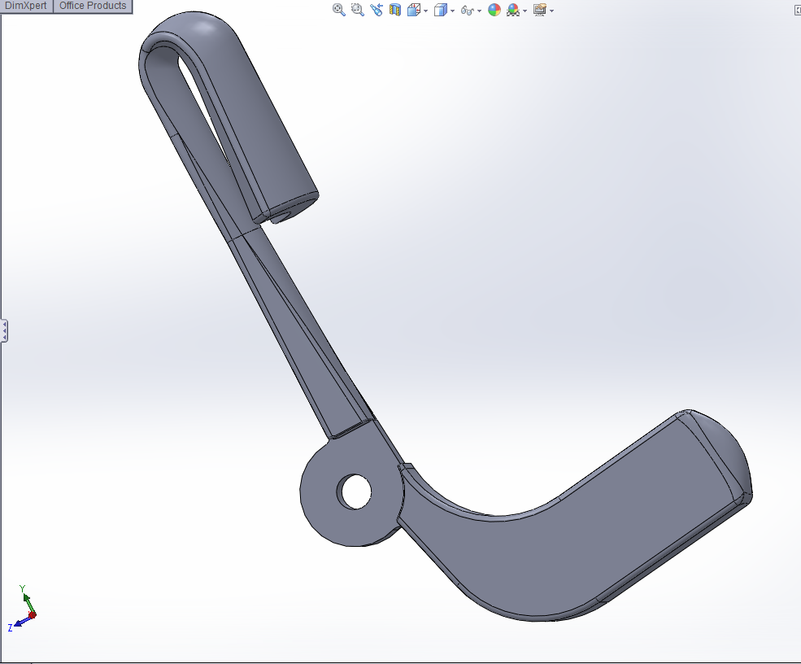
Figure 2: Shows one of two identical meshing elements which form the bottle de-capper

A pneumatic system powers the bottle de-capper. A robotic arm guides the de-capper to the cap of the 5 gal bottle. When it is in place, the contraption above will be lowered into the hole of the cap in the center. When it is in place and the gripper is fully inside the cap, the actuator powered by gas-compression pushes the arm closer together, forcing the gripper to separate. This makes the diameter of the de-capper larger than that of the hole of the cap. So, when the arm pulls out, the gripper wedges the cap and it pops out.
Mechanism
The cap that is to be opened has an inside diameter of 19 mm and a length of 15 mm. The outside diameter is 57 mm and they all have an overall thickness of 1 mm. With these design parameters in mind, we designed a de-capping mechanism which has a diameter of less than 19 mm when entering the cap and then expands so that it is bigger than the inside diameter of the cap. This ensures that when the actuator lifts up the de-capper, it applies a high amount of pressure on the edge and this pops the cap out.
When the de-capper is lowered, it hits the inside cap of the bottle and pushes it open. With it open, it proceeds to go in and decap the bottle. The de-capper has a gripper which is 45 mm from pivot to end. This gives it more than enough allowance to open up inside the cap. When unopened, the tip of the gripper is 18 mm in length and when opened, it reaches a length of 48 mm.

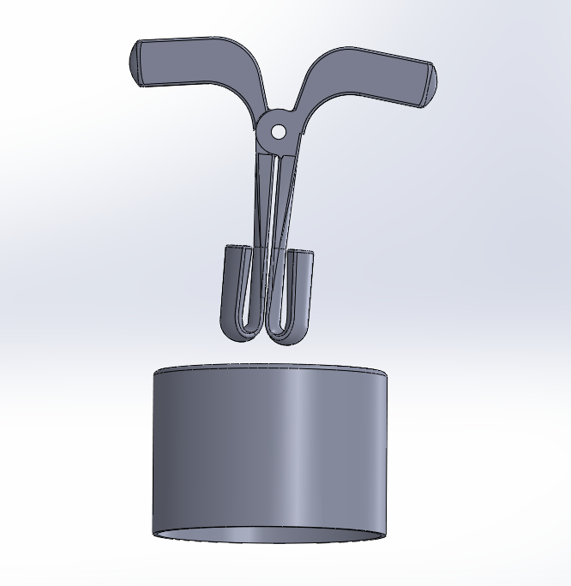
Figure 3: Shows the de-capper right before it enters the cap
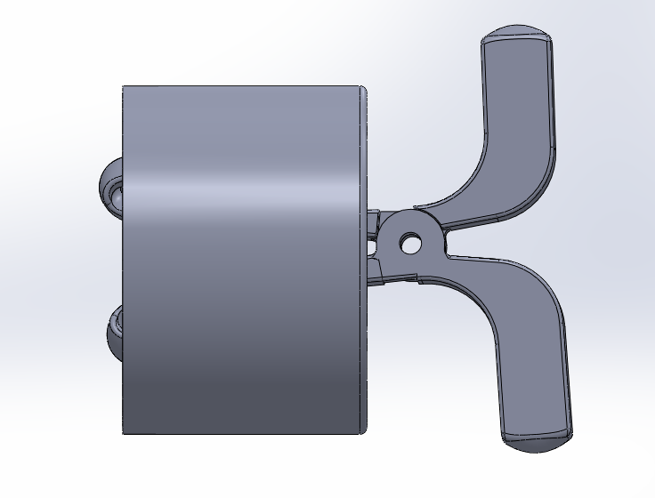
Figure 4: Shows the de-capper when it is inside the cap
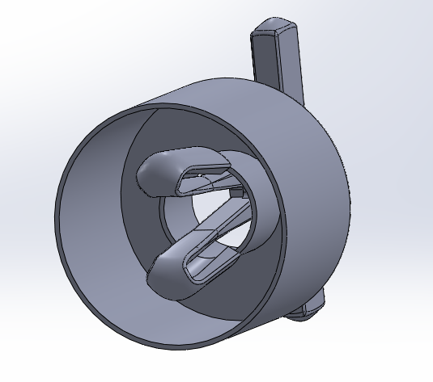
Figure 5: Shows a better view of how the de-capper fits into the bottle cap

