|  |  |
| --- | --- |
|  | **MECH 447** |
|  | Rao, Manu Vengeta  Kathirasen, Kathirgugan  Kong, Liran  Zhang, Dingwei |

UNIVERSITY OF NEBRASKA-LINCOLN

DEPARTMENT OF MECHANICAL AND MATERIALS ENGINEERING

Prepared for:

**William Bill Dick**

Instructor of Mechanical Engineering

University of Nebraska-Lincoln

|  |
| --- |
| **[Load-Triggered Walker]** |
| MECH 447 - Senior Design Capstone Project |

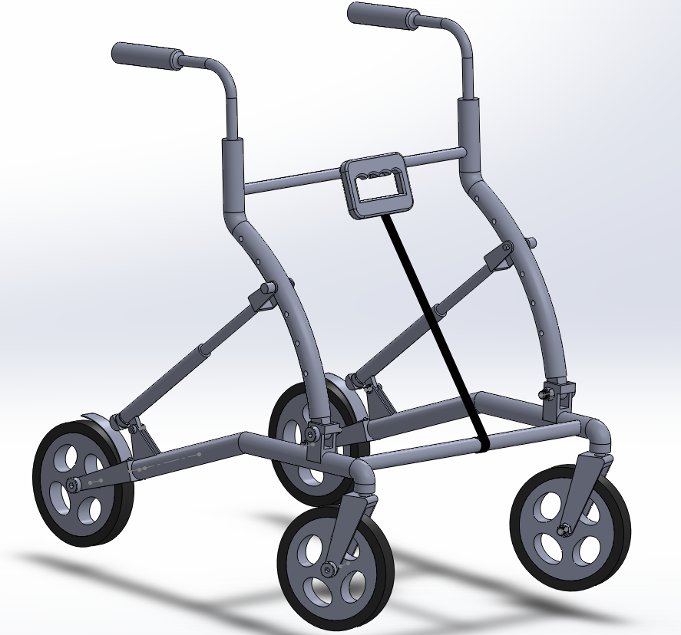

Table of Contents

Table of Figures 4

Executive Summary 5

Introduction 6

Background 7

Market Research 7

Patent Search 8

Design 12

The Retractable Ball Point Pen mechanism (Cam and Ratchet Mechanism) 13

The Arc Mechanism 16

Mobility 18

Force Analysis for Critical Components 19

Force Analysis for Non-Critical Components 27

Cam and Ratchet Mechanism 30

Design for Manufacture 30

Design for Assembly 32

Overall Walker 35

Design for Manufacture 35

Design for Assembly 36

Costing 36

Conclusion 37

Appendix A 38

Appendix B 42

Bill of Materials 42

Appendix C 44

Manufacturing Costs Estimate 44

Cam-Ratchet Mechanism 44

Walker 45

Appendix D……………………………………………………………...................................................................................46

Appendix E…………………………………………………………………………………………………………………………………………….47

# Table of Figures

Figure 1: Duro-Med 2-Button Adjustable Aluminum Folding Walker ($45.99) 6

Figure 2: NOVA "GetGo" 4203 Rolling Walker ($99.99) 7

Figure 3: Design for the Anti-Tipping Device for Walkers patent design 8

Figure 4: Invalid Walker with Wheel Control Mechanism patent design 8

Figure 5: Impact Braking Device patent design 9

Figure 6-15: Solidworks drawing of our load-triggered walker 10

Figure 16: Difference in angle that corresponds to the change in the arc notch 15

Figure 17: How the walker would be folded 16

Figure 18: Pin folding mechanism 17

Figure 19: Handle which has Velcro padding 17

Figure 20: Cam under a load of 150 lbs. 18

Figure 21: Ratchet under stress.. 19

Figure 22: Follower under stress 20

Figure 23: Shaft under stress. 21

Figure 24: Specifications of the magnet. 22

Figure 25: Force Vs. Distance graph for magnet. 22

Figure 26: Technical specifications of the compression spring 23

Figure 27: Load on handlebars 24

Figure 28: Load on arc mechanism 25

Figure 29: Load on base 25

Figure 30: Stress analysis on the castor handle. 26

Figure 31: Plasticized PVC brake pad under stress. 26

Figure 32-36: Exploded view of the cam and ratchet mechanism. 27

Figure 37-39: Main parts of the walker 32

# 

# Executive Summary

This report details an alternative design for a walker mechanism for the elderly and disabled. The walkers in the market currently are ones that have a hand-triggered mechanism. Although it has proven effective, Madonna Rehabilitation Hospital has identified the need for a load-triggered mechanism which could retard the fall of a person who accidentally slips.

The design proposed here has a braking and locking mechanism which is engaged and disengaged based on the amount of vertical force being applied by the user. It incorporates a retractable ball point pen’s design mechanism to achieve this. A ball point pen has a cam and ratchet mechanism which acts in unison to push out the pen nib when the clicker is clicked and then subsequently to retract it when clicked again.

The way the walker’s locking mechanism differs from a traditional ball point pen is that the mechanism is used for structural purposes and needs to be able to support a certain amount of load. To enable this, it is to be made so AISI 304 Steel, which has a very high tensile strength. A novel idea incorporated into the device is the introduction of a neodymium magnet. This acts as a stabilizing factor when a person’s weight pushes down on the walker’s handle.

Because of the nature of the mechanism being proposed, we encountered a problem early on where a simple push on the handle would activate the cam and ratchet mechanism. This was undesirable and so the magnet was fitted in. This eliminated the problem and added a certain amount of stability into the device. Hence, to activate the mechanism, the user has to overcome the initial force of the magnet.

This still left us with the problem of having to build walkers of different specifications to cater to the diverse demographic who we anticipated to be potential customers. To overcome this, an arc was incorporated into the walker handle design which allowed for a range of users according to their weights. This ensured that a heavy person would be able to use the walker just as easily as a light person.

Some of the parts will be fabricated using the rapid prototyping machine while most parts may be purchased commonly. A detailed bill of materials is included in Appendix B.

# Introduction

The load-triggered automatically locking walker is a design idea proposed by Madonna Rehabilitation Hospital in Lincoln, NE. They expressed need for a walker catering to those with impaired balance and decreased strength which would offer safer mobility than conventional walkers in the market.

Madonna Rehabilitation Hospital needs a walker that does not slide out from under the user when an off-vertical force is applied. We have been tasked to design a walker which can support significantly more inclined incident forces while remaining stable in the horizontal plane; in particular, a device whose resistance to rolling/sliding adapts with the magnitude of applied load.

The design that we are to propose should eliminate the need for the person using the walker to use a hand-triggered brake or any other type of manual braking mechanism. This project is aimed at designing an inexpensive load-triggered walker for the elderly and disabled.

There are two major design elements that need to be addressed here: the need for mobility and the need for an effective fall prevention mechanism. The issue to be considered is how to increase one without reducing the other as they inversely correlate.

# Background

## Market Research

There are a myriad of walkers in the market but they can all be roughly categorized into two major classes: those with an active locking mechanism and those without.

Those without an active locking mechanism are the cheapest and most common. They are the standard in medical centers and most households. They have four legs where the two back legs are fitted with slip resistant rubber tips while the two front legs have wheels attached to them. In the case of a fall, the rubber tips would function as brakes to retard motion. An example of such a walker is provided below.

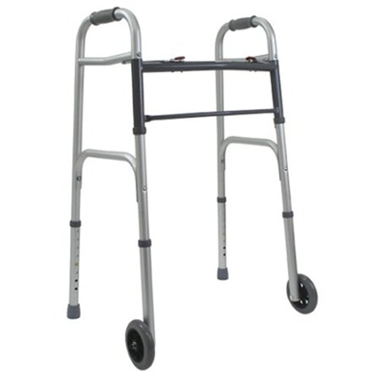

Figure 1: Duro-Med 2-Button Adjustable Aluminum Folding Walker ($45.99)

The other category is those which have an active locking mechanism. After doing extensive market research, we found that an overwhelming number of these type of walkers have a manual hand-triggered brake, similar to those on bicycles. They have four wheels and they are fitted with a rubber padding which comes in contact with the wheels when the hand brake is pulled. An example is shown below.

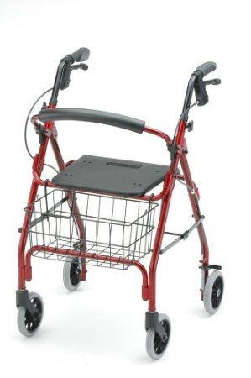

Figure 2: NOVA "GetGo" 4203 Rolling Walker ($99.99)

### Patent Search

After an exhaustive patent searching process, the three most relevant patents were chosen. They are provided below and excerpts from the patents are provided in the appendix.

1. Anti-Tipping Device for Walkers (Patent No: US 7,779,850)

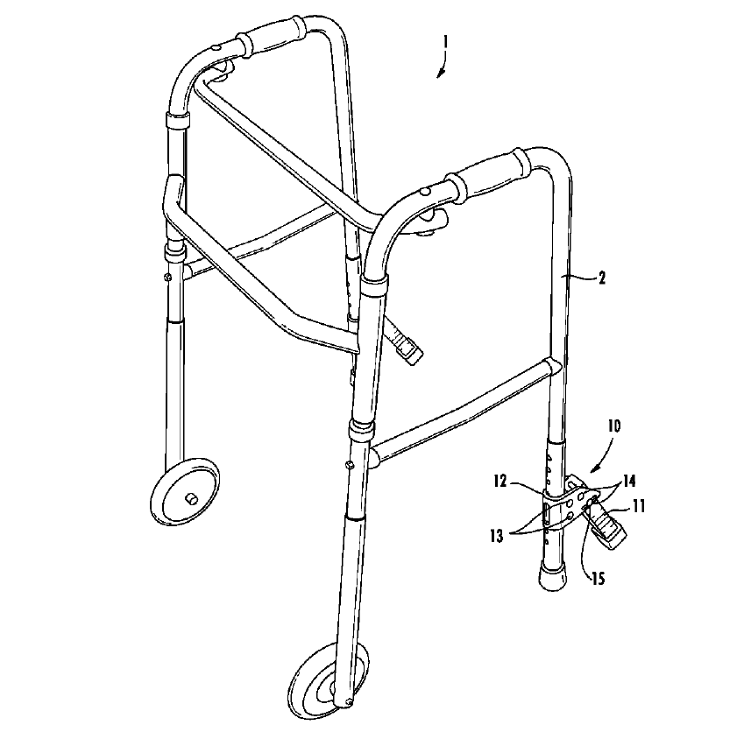

Figure 3: Shows the design for the Anti-Tipping Device for Walkers patent design

1. Invalid Walker with Wheel Control Mechanism (Patent No: US 4,018,440)

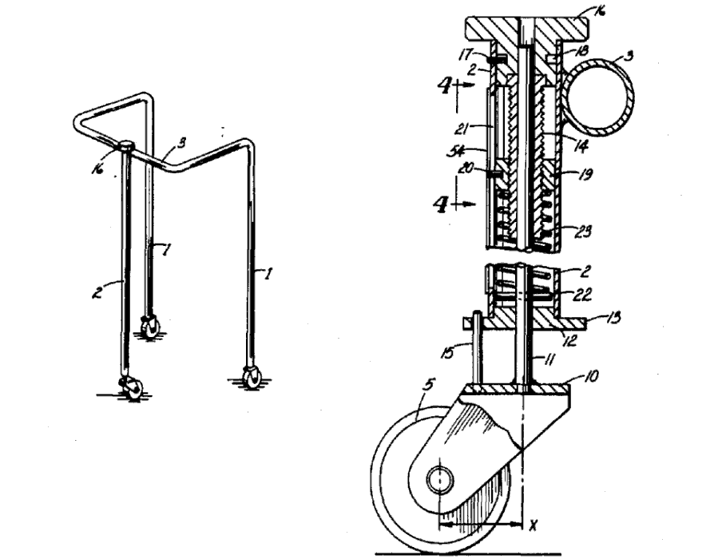

Figure 4: Shows the Invalid Walker with Wheel Control Mechanism patent design

1. Impact Braking Device ( Patent No: US 3,945,672)

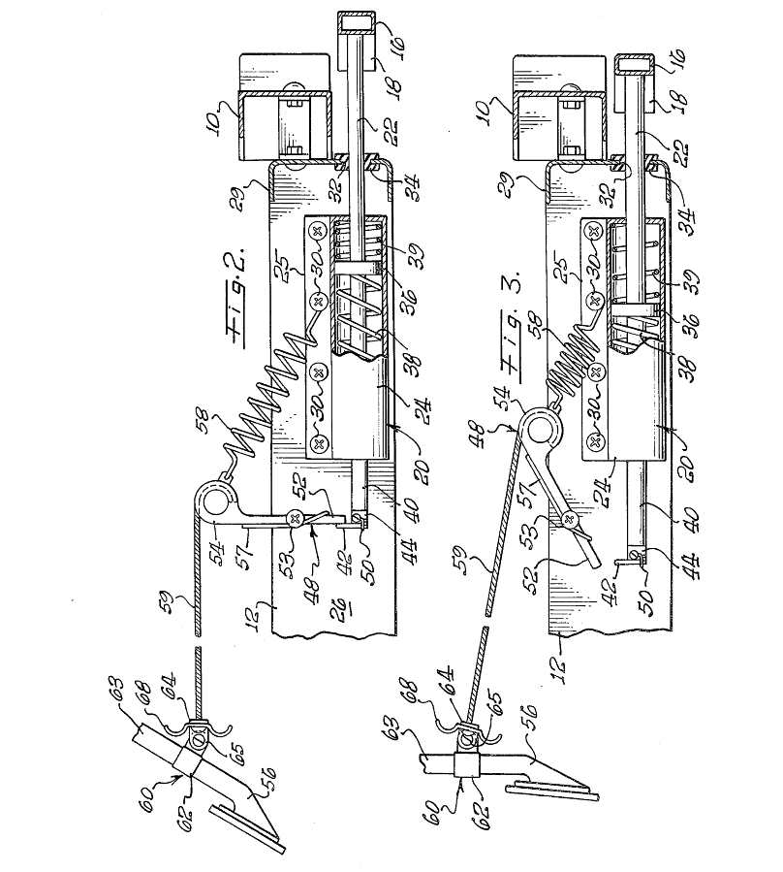

Figure 5: Shows the Impact Braking Device patent design

After considering the different patents and designs in the market, we came up with the conclusion that there is a serious need for an automatic locking mechanism in a walker. The first patent design was deficient in the sense that although it would stop a person from falling backwards, it would be powerless to stop horizontal motion.

The second patent had a locking system which was based on the number of wheel revolutions which would deprive the user of his/her control. The third patent seemed the most similar to what we were considering. However, the locking mechanism itself seemed a little too complicated to be installed in a walker which was to be as light and cost-effective as possible.

# Design

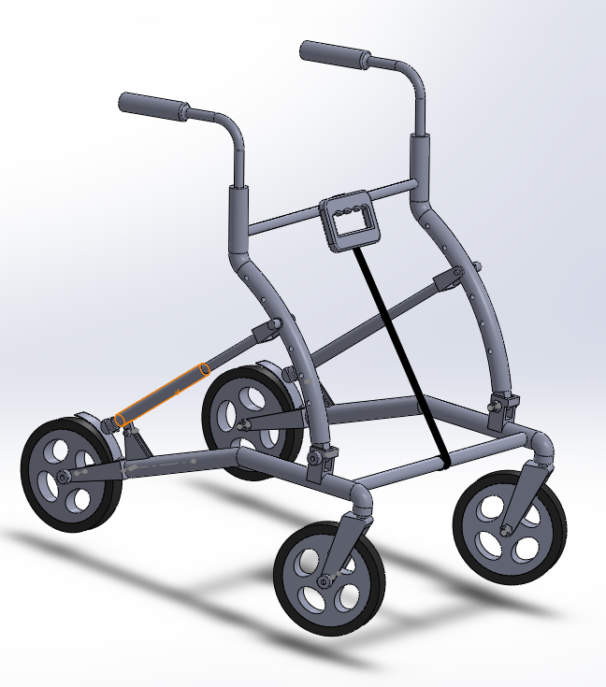

Figure 6: Shows a Solidworks drawing of our load-triggered walker

## The Retractable Ball Point Pen mechanism (Cam and Ratchet Mechanism)

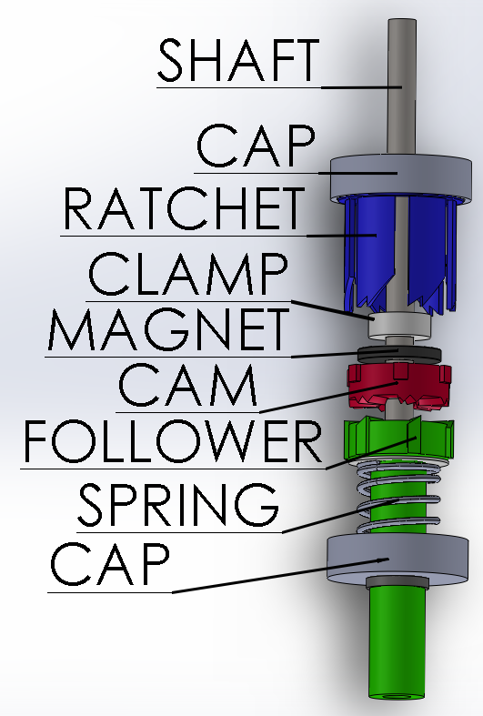

Figure 7

The image to the left shows an exploded view of the ratchet-cam mechanism, with the most important parts labeled.

The shaft goes through the entire mechanism and is allowed to slide freely up and down. The clamp is rigidly attached to it. The shaft goes through the follower as well, which itself is allowed to move freely up and down. A compression spring maintains an upwards force. The cap is made of galvanized steel so that the magnet can attach to it.

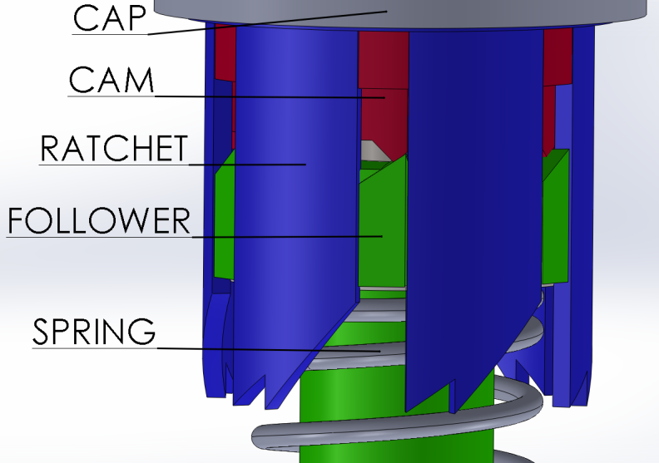Initially, the entire mechanism is at rest where the follower is aligned with the ratchet. At this state, the spring is completely at rest and encounters no compression. The mechanism is able to dwell in the rest position because the follower fins are aligned with the ratchet slots. This phase is known as the dwell phase of the follower. This is when the brake pads are retracted and are not in contact with the wheel.

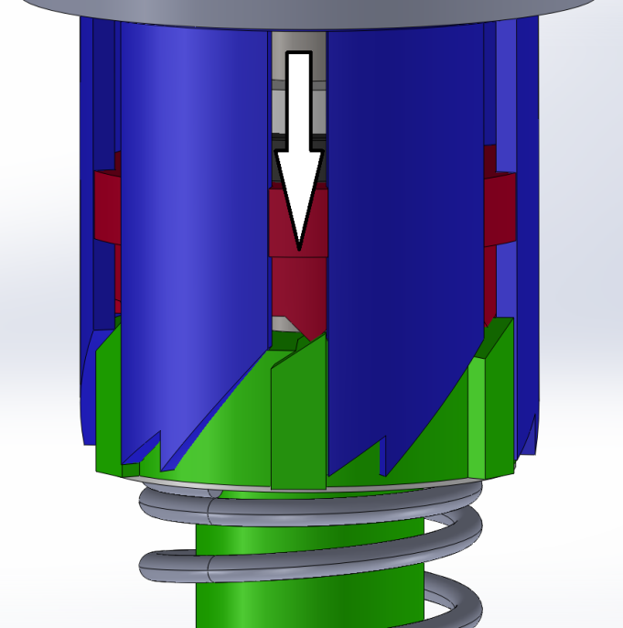When the user applies his/her weight by pressing on the walker handle, a certain force threshold has to be overcome to disengage the neodymium magnet. When the magnet is disengaged, the cam moves, forcing the follower to push the spring while exiting the slots of the ratchet.

Figure 8

Figure 9

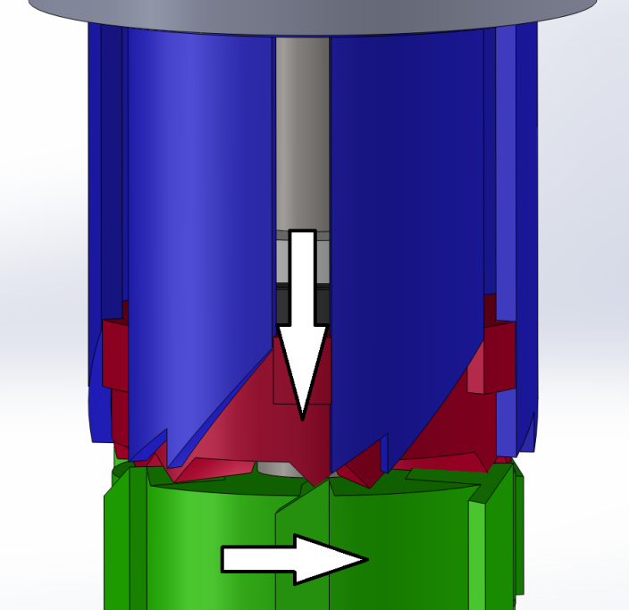

Figure 10

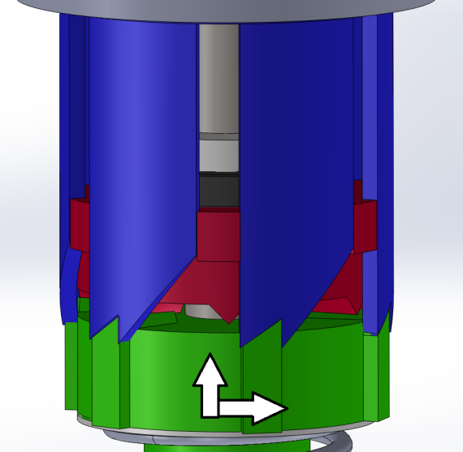Due to its new displacement, the follower rotates to an intermediate location where the slots and fins are not aligned and so cannot slide into one another. This is accomplished by the specific geometry of the cam and ratchet. This geometry is shown in detail on the left.



Figure 11

At the completion of this phase which is called the rise phase, the follower dwells on the ratchet. At this time, the brakes pads are extended and they are in full contact with the wheels, hence retarding the motion of the walker and bringing it to a complete halt.

Figure 12

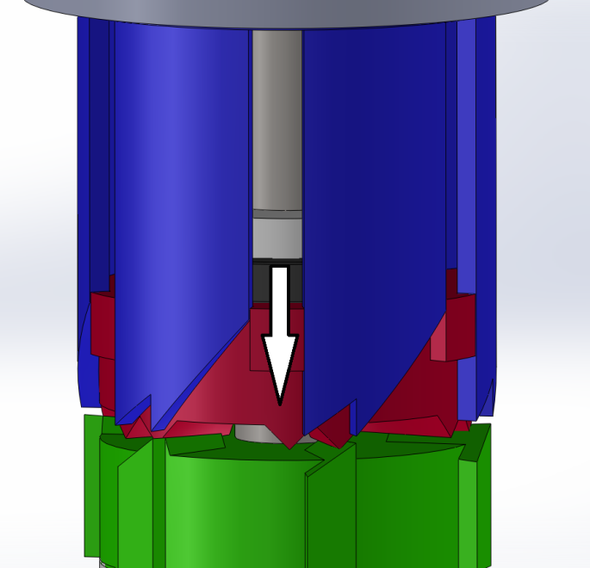When the user wants to start moving again, he/she once again exerts a force on the handle of the walker. This action would transfer the force to the cam mechanism which then pushes and rotates the follower to an intermediate position so that the fins are not at rest either on the cam or in the cam slots.

Figure 13

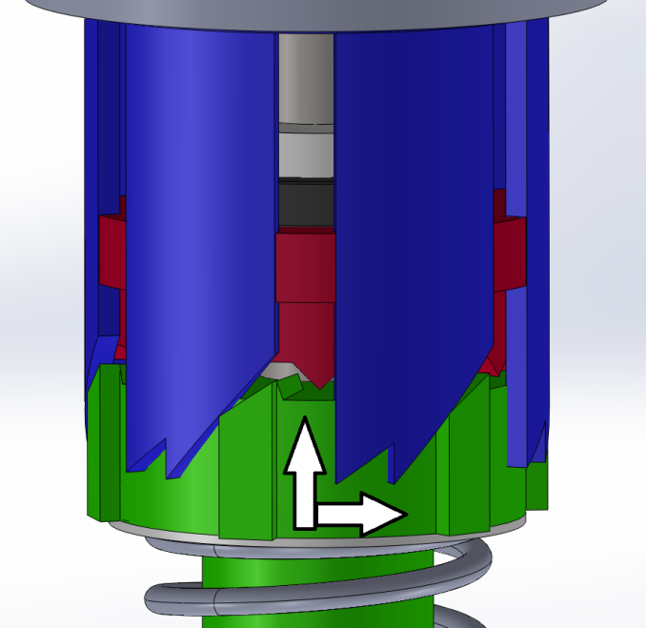

Figure 14

During this phase called the fall phase, the spring starts to decompress to its equilibrium position.

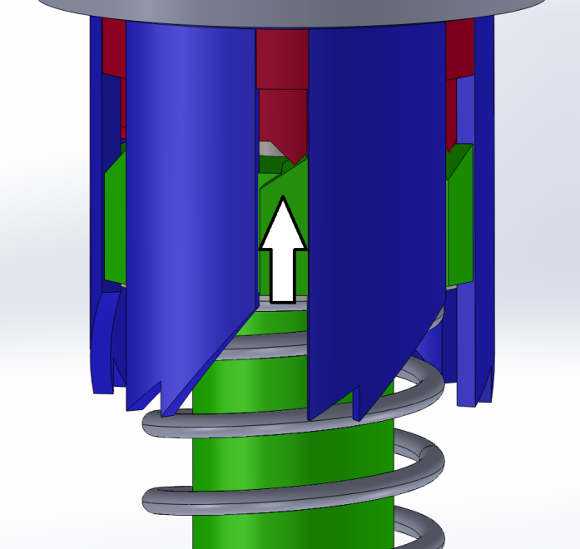

The cycle is complete when the follower fins are aligned in the ratchet slots and the magnet is fully engaged to the metal plate. This in turn retracts the brake pads from the wheel and the walker is mobile again.

Figure 15

## The Arc Mechanism

The arc mechanism is another crucial part of the walker. This is the part that allows people of different weights to be able to use the walker effectively. The arc itself is part of the handlebar and the notches incorporated in it allow for varying degrees in force transference. Having the walker on the topmost notch would allow for 82% of the force input to activate the brake. This would be very handy for a person who is light and can only exert a relatively small amount of force.

On the other hand, the bottommost notch would allow for 180% of the force input. This would be used for a much heavier person who wouldn’t want the walker compressing for every step that he/she takes. The table and graph below work to illustrate the relationship between the angles of the notch’s location to the amount of force needed to lock it. The shaft of the retractable pen mechanism, which would connect to the notch, would then be allowed to be adjusted according to the person’s weight specifications.

For example, our design utilizes a magnet that requires each a load of approximately 10 lbs to disengage. This means that a weightier person could adjust it so that 18 lbs is required to engage the brakes. On the other hand, grandma can apply the brakes with just 8 lbs of force. Couple this with the fact that the magnet and spring are incredibly common and come in many ratings and the customizability becomes sufficient to cover the entire range of anyone the Madonna Rehabilitation Hospital deems fit to use this device.

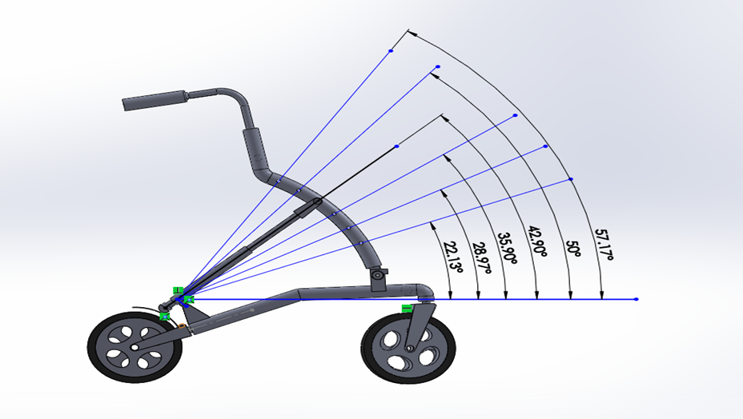

Figure 16: Shows the difference in angle that corresponds to the change in the arc notch

|  |  |
| --- | --- |
| Angle(°) | F-Tube |
| 22 | 1.83F |
| 29 | 1.42F  *Table 1: Shows the force displacement that corresponds to the arc’s angles* |
| 36 | 1.17F |
| 43 | 1.01F |
| 50 | 0.90F  *Graph 1 (below): Illustrates the relationship between force factor and angle* |
| 57 | 0.82F |

## Mobility

The walker can be folded downwards. This is illustrated in the figure below. Unlike conventional walkers which fold sideways, this unique design ensures the user maintains maneuverability even when the walker is folded.

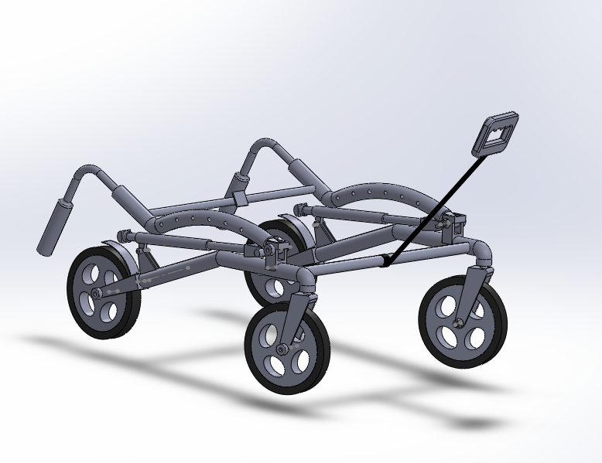

Figure 17: Shows how the walker would be folded

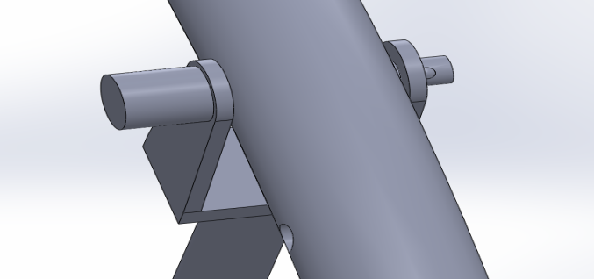

The folding mechanism also ensures that a great deal of storage space is saved when it is to be kept away. As can be seen, the pin at the top end of the cam and ratchet mechanism can be disengaged and this causes it to drop. The absence of this impediment means the arc mechanism along with the handlebar can be pushed down.

The durable nylon strap which is attached to the lower horizontal bar is connected to a handle. This handle is connected to the top bar via a Velcro strap. This means that when the walker is being used, the strap is attached to the upper horizontal bar and when it is to be folded, the Velcro can be disengaged and be used as a handle to pull the walker around. The Velcro strap was made sure to be highly durable so as to ensure that it doesn’t give way after some time.

The strap also serves another purpose. When it is to be stored in the car, the user can easily pull the strap up, grab the lower bar and place it in the car.

Figure 18: (shown as A on figure 8): Shows the pin mechanism that if pulled in the direction shown, would disengage and allow the walker to be folded

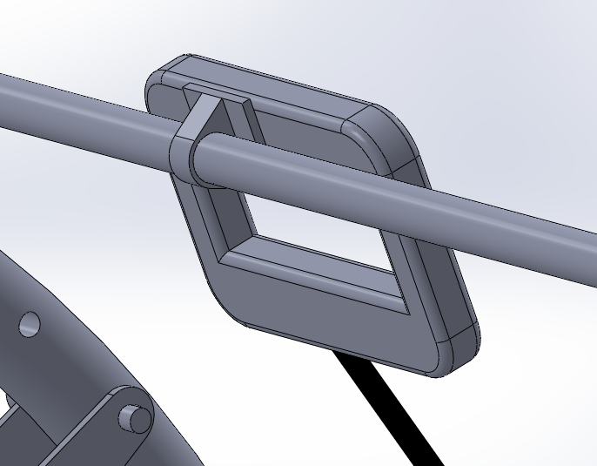

Figure 19: (shown as B on figure 8): Shows the handle that is attached to the upper horizontal bar which has Velcro padding

# Force Analysis for Critical Components

Two force analyses were done to accurately predict the effect a person’s weight would have on the walker. The first was a piece by piece force analysis where the entire walker was studied by applying a load of 300 lbs. on the handlebars. This particular weight was chosen as we took that as the weight of heaviest person who we anticipate to use the walker. The second analysis was done specifically on the cam and ratchet mechanism which was identified as the most critical component in the mechanism. All the force analysis was done using the Solidworks’ Simulation Xpress Analysis Wizard software as it provides accurate and visual results.

All parts were made sure to have a safety factor of 2 to ensure that the mechanism is safe to operate and would not undergo failure.

## Cam

## E:\cam force.png

Figure 20: Shows the cam under a load of 150 lbs. As can be seen, the Simulation Wizard also shows when a safety factor of 2 is not obeyed. Since there is no discoloration, it shows that the cam is well above a safety factor of 2.

It should be noted that the **purple arrows** indicate the direction of force while the **green arrows** indicate the constrained surface. The material used for the cam, ratchet, and follower is ABS plastic which has a tensile stress value of 30,000,000 N/m2.

The equation for safety factor is shown below:

$Safety Factor=\frac{Yield Strength of Material}{Maximum Stress being exerted}$…………. (1)

The above equation was used for all ensuing factor of safety calculations.

$$SF= \frac{30000000}{1316484}=22.79$$

## Ratchet

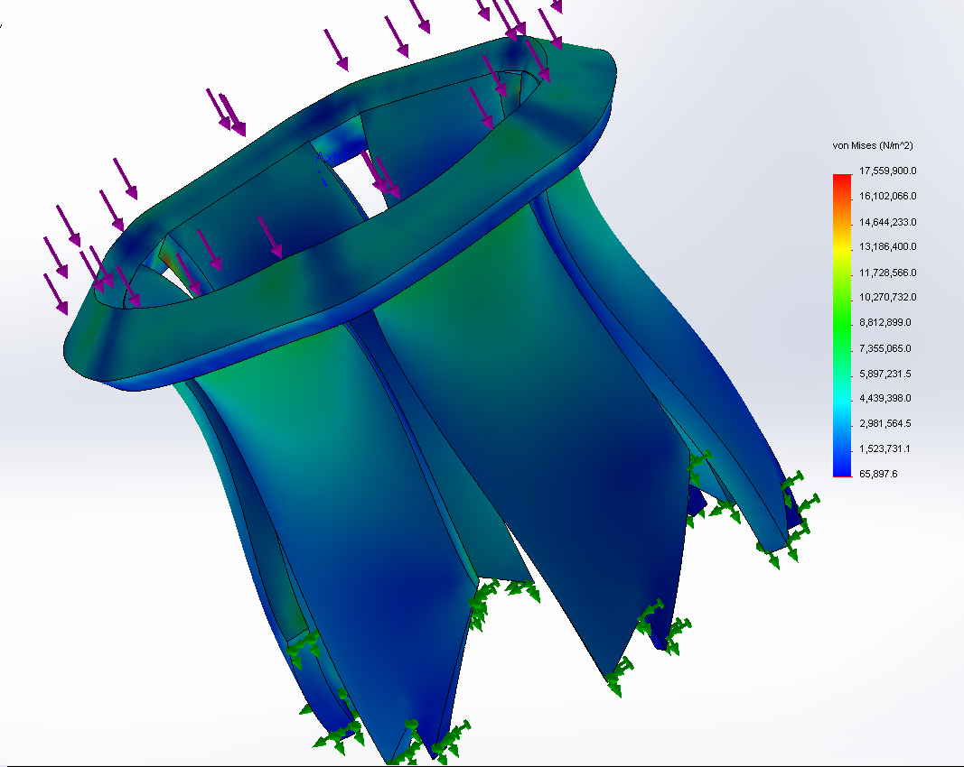

Figure 21: Shows the ratchet under stress. The deformation that is shown is merely a simulation and is not representative of a real life situation. This is as the ratchet sits inside the metal tube which would hold it in place. Its factor of safety is 1.71.

This is the only part with a safety factor that dips very slightly below 2. However, the part is designed to splay outwards, as under operating conditions it is tightly surrounded by the A304 tube. Thus, its safety factor of 1.77 is considered sufficient.

## Follower

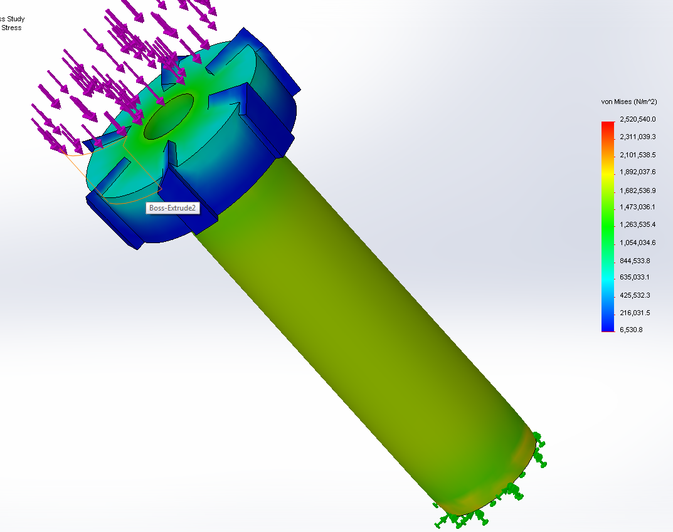

Figure 22: Shows the follower under stress. Its factor of safety is 11.90

The follower was designed with a high factor of safety as it is a structural element that is meant to support the full weight of the user. ABS plastic was chosen as it has a strong compression strength as well as high toughness.

## Shaft

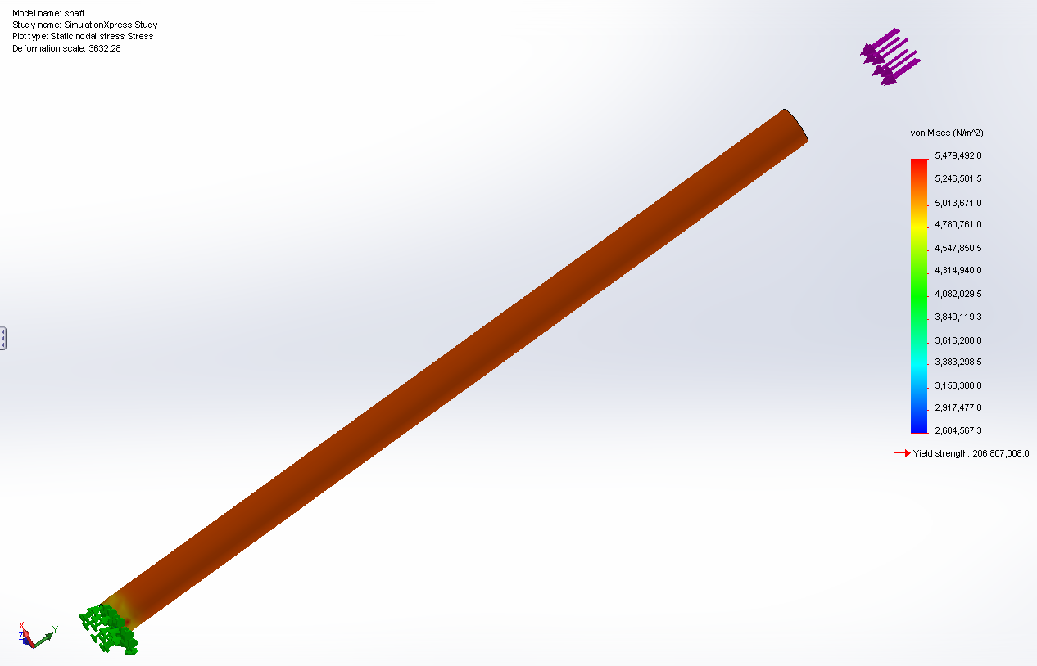

Figure 23: Shows the shaft under stress. It has a safety factor of 37.74

The shaft has the highest safety factor for several reasons. Firstly, a diameter of ½” was considered reasonable in terms of commonality. Secondly, this part has the role of supporting all the other parts radially, while at the same time proving axial support to the walker frame and user. Also, A304 Stainless Steel was chosen as it is not affected by the magnet, the same reason for the tube being of the same material.

## Magnet

The walker has to be rigid and not bouncy when being moved by the user. The problem with the cam and ratchet mechanism without the use of a magnet is that the slightest weight exertion on the walker would force it to compress due to the spring inside. This would make it bouncy, and for people, who above all else need support, it would prove highly undesirable. To overcome this, a powerful neodymium magnet was fitted inside. This acts to provide the stability and support needed by the user.

The magnet can only be disengaged when a certain force threshold is exceeded and until it is, the walker is rigid and doesn’t move up and down. The magnet that was chosen is shown below, along with its force graph.

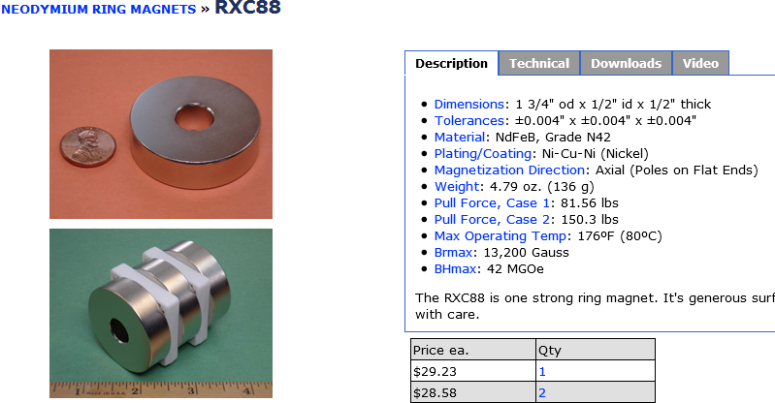

Figure 24: Shows the specifications of the magnet of choice.

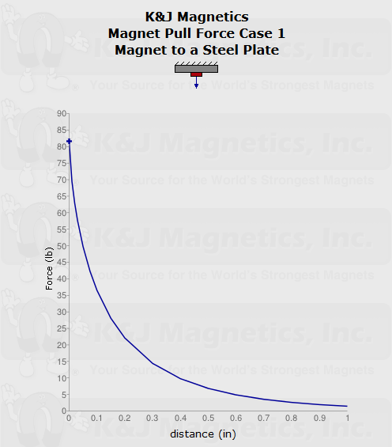

Figure 25: Graph shows the Force Vs. Distance graph for the neodymium magnet.

The part that holds the magnet in place is the clamp. The clamp has a thickness of 0.4 in. Therefore, the galvanized steel cap doesn’t come in direct contact with the magnet, but the clamp. Due to this, at initial position, the steel cap and the magnet are 0.4 inches apart. When the graph above is referred to, a distance of 0.4 inches corresponds to a force of approximately 10 lbs. In total, for the two cam and ratchet mechanisms in the walker, it would be 20 lbs. This is the initial force that has to be overcome by the user to disengage the magnet and employ the locking mechanism. However, due to the unique arc mechanism (page 9) that has been expanded upon before, the force needed to disengage the magnet can be varied according to the weight requirements of the user.

## Spring

The specification sheet below enumerates the spring’s characteristics. As can be seen, the most important information that would be used to choose an appropriate spring is its Maximum Load and Spring Rate. They are 14.00 lbs. and 6.80 lbs./in respectively.

The load that the spring would be expected to bear is the force required to disengage the magnet. From the magnet’s specifications, it will be exerting a force of approximately 10 lbs. This is well within the maximum load that the spring can take, which is 14 lbs. This is the reason this particular spring was chosen.

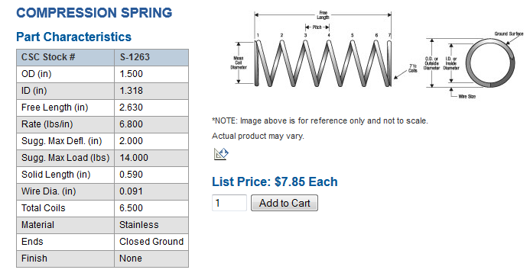

Figure 26: Shows the technical specifications of the compression spring chosen.

# Force Analysis for Non-Critical Components

## Part-by-part Analysis

### Handlebar

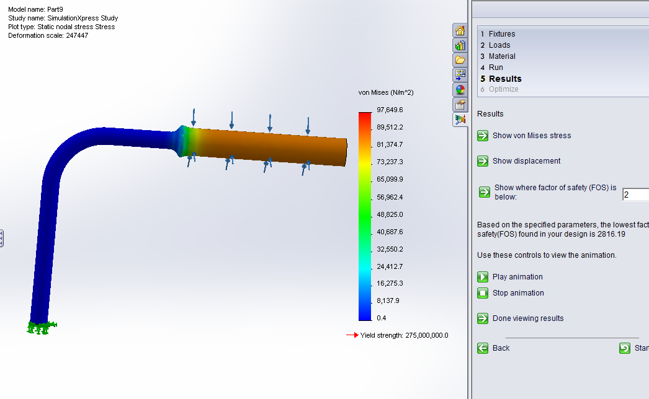

Figure 27: As can be seen above, Solidworks shows that when the bottom of the handlebar is constrained and the top receives 150 lbs. (300 lbs. on both handlebars)

The stress generated is well above the safety factor of 2. This proves that the handlebar would easily be able to take the weight of the user.

From the figure above, we can find the **maximum stress** and the **yield strength**

$$SF=\frac{275000000}{97649.6}=2816.19$$

### Arc Mechanism

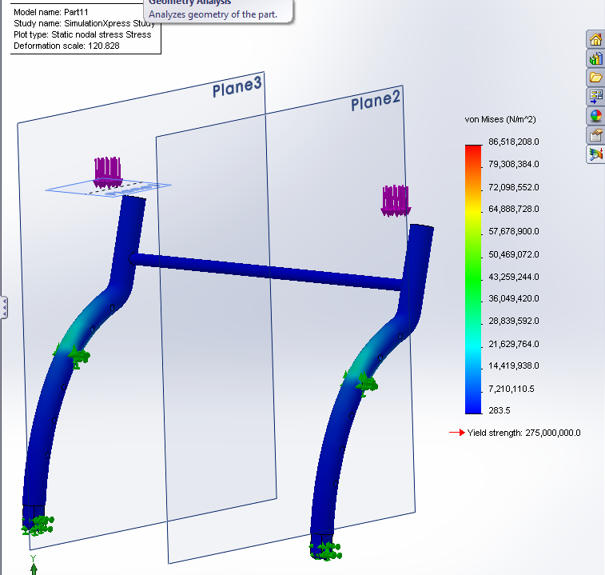

Figure 28: Shows the arc mechanism when a load of 300 lbs. is applied to the top of the bar which connects to the handlebar. The equation (1) shown above was used to calculate the safety factor and it is 3.17.

### Base

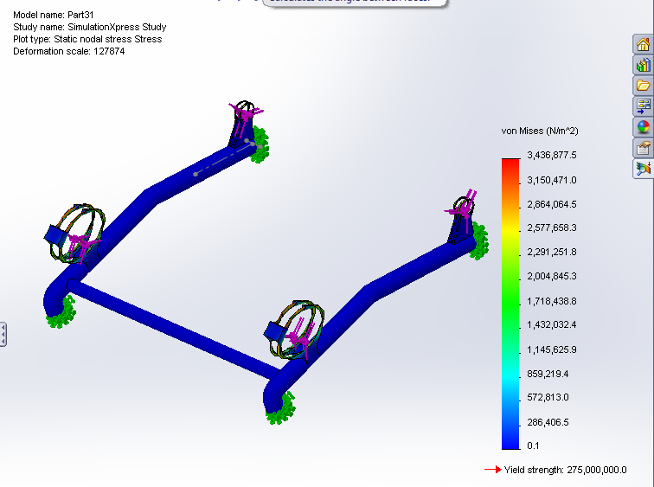

Figure 29: Shows the base under the force of the user. The factor of safety can be calculated to be 83.33.

### Castor Handle

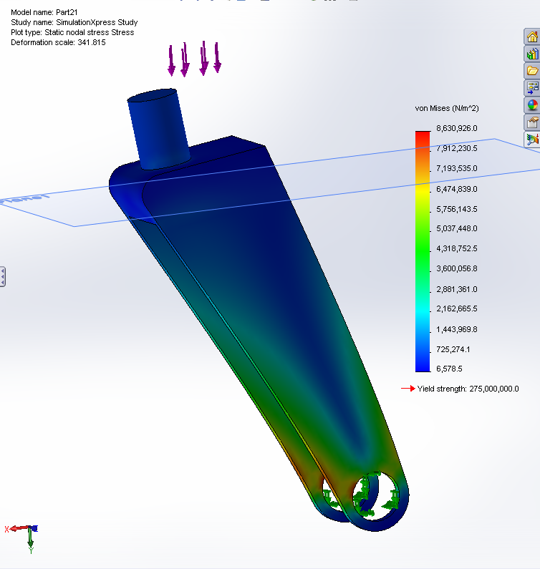

Figure 30: Shows the stress analysis on the castor handle. The factor of safety is 31.86

### Brake Pad

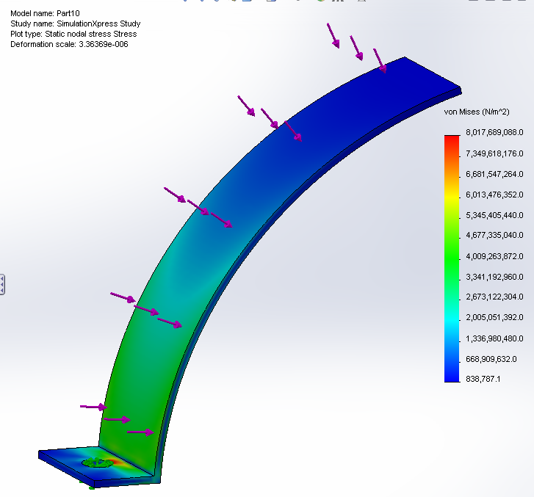

Figure 31: Shows the Plasticized PVC brake pad under stress. The factor of safety is 3.27

# Cam and Ratchet Mechanism

## Design for Manufacture

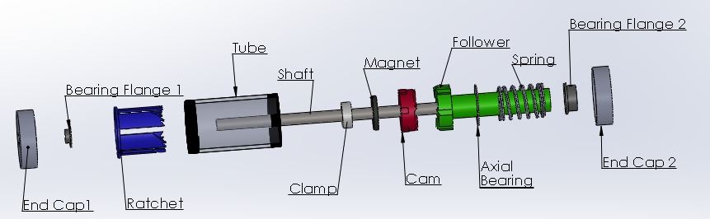

Figure 32: Shows an exploded view of the cam and ratchet mechanism.

The ratchet-cam mechanism consists of ten separate components. Three of these are manufactured while the rest may be purchased. Each mechanism requires a hollow tube to contain it. This tube a 2” schedule 40 seamless pipe made of 304 stainless steel. It is 4” long. It is threaded on both ends according to MNPT specifications. In order to reduce secondary operations, the pipe is purchased already threaded in the form of a 4” nipple from Global Industrial.

To enclose both ends of the pipe and to provide a surface for the magnet to attach, 2 malleable galvanized iron threaded end caps are purchased from Global Industrial. These end caps are also 2” nominal diameter and threaded according to schedule 40 specifications. The center of one cap (End Cap 1) is bored to 0.750” diameter in order to allow for the fitting of a flanged liner bearing, while the other (End Cap 2) is bored to 1.125”.

The flanged bearings consist of a steel backing and an inner liner made of sintered bronze and PTFE. These are purchased from QBC. One (Bearing Flange 1) has a 0.5000” bore, 0.5938” outer diameter, with a length of 0.2500”. The other (Bearing Flange 2) has a 1.0000” inch bore, an outer diameter of 1.1250” and is 0.5000” in length.

A 0.5” diameter shaft goes through the entire assembly. This shaft is made of 304 stainless steel and is 12” long. The shaft is purchased in 6 foot lengths from Ace Stainless Supply. They must then be cut to length. The shafts come with a semi-smooth finish.

In order to transmit axial force from the shaft into the magnet and subsequently the cam, a shaft clamp is required with a 0.5” bore. This clamp is purchased from Global Industrial. It is made of steel so that more force is transmitted by the magnet into the end cap, reducing the need for a larger magnet. When selecting clamps, care should be taken to ensure that its thickness is 13/32” so that the correct amount of force is exerted by the magnet onto the end cap, as the force varies greatly by distance.

The magnet that holds the shaft in place is made of neodymium-boron of class N42. It has an inner diameter of 0.50”, an outside diameter of 2.00” and a thickness of 0.25”. The magnet is purchased from K & J Magnetics.

The axial bearing allows for the rotation of the follower relative to the spring while transmitting the axial force. This bearing is made of PTFE. It has in inner diameter of 1” and an outer diameter of 1.8”. The axial bearing is purchased from Boker’s Inc.

Finally comes the ratchet, cam and follower. These are all made of ABS. In smaller production runs, they may be produced in a 3D printer. However, for larger runs, custom injection molding would be the most cost effective method of producing the three parts. Further manufacturing details are located in Appendix C. Detailed drawings of the parts are located in Appendix D.

## Design for Assembly

The assembly instructions for the mechanism are as follows.

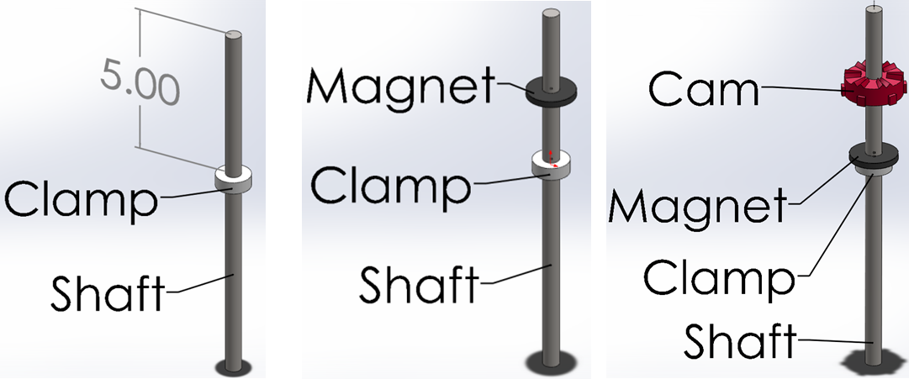

**“**

11

2

Figure 33

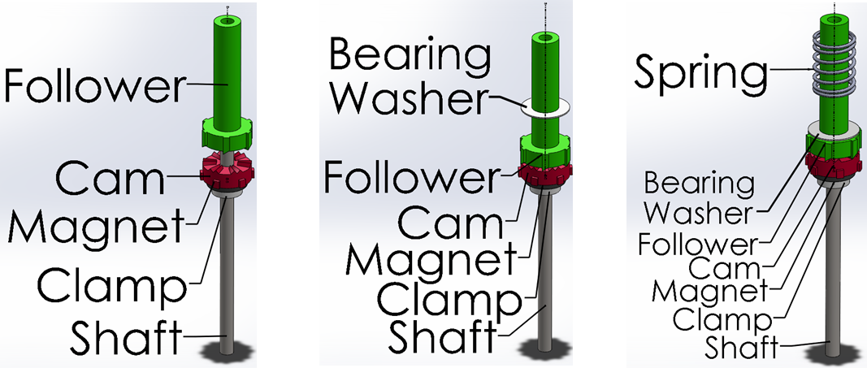

Figure 34

*1) Clamp according to manufacturer’s instructions

2) Flat side down

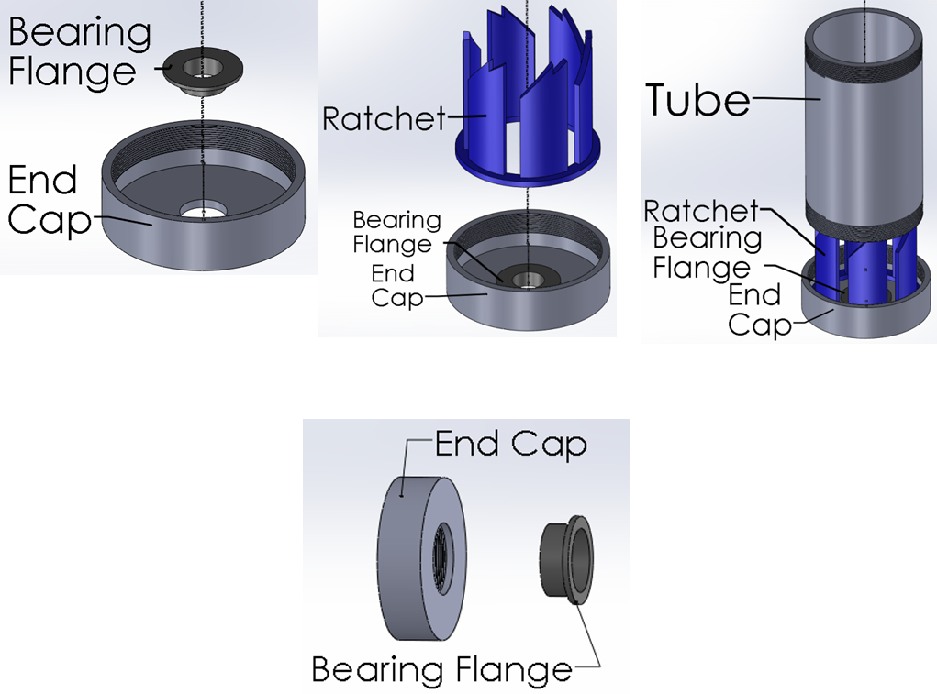

Figure 35

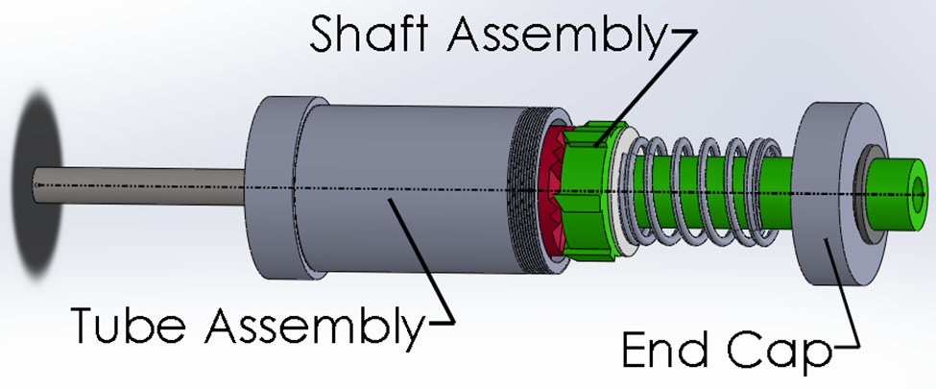

Figure 36

### Shaft Assembly

1. Attach Clamp to Shaft according to manufacturer’s instructions so that the topside of Clamp is 5” from end of rod.
2. Slide Magnet onto Shaft so it sits on the topside of the Clamp.
3. Slide Cam onto Shaft so that the flat side faces Clamp.
4. Slide Follower onto Shaft with thicker end facing Cam.
5. Slide Bearing Washer onto Follower.
6. Place Spring around Follower.

### Tube Assembly

1. Press fit Small Bearing Flange into End Cap 1.
2. Place Ratchet within End Cap 1, flat side facing the End Cap 1.
3. Thread Tube into End Cap 1 hand tight.

### End Cap 2

1. Press fit Large Bearing Flange into End Cap 2.

### Entire Mechanism

1. Insert Shaft Assembly, Clamp side first, into Tube Assembly.
2. Thread End Cap 2 onto Tube Assembly.

# Overall Walker

## Design for Manufacture

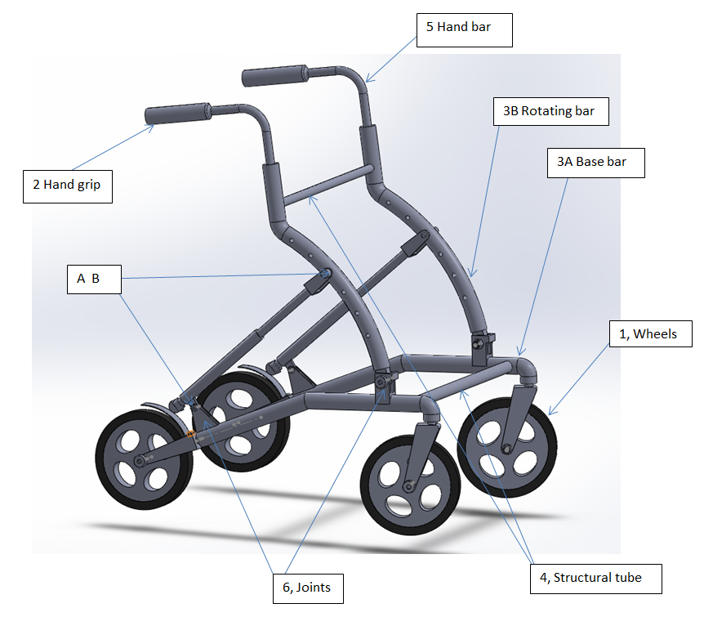

Figure 37: Shows the main parts of the walker, fully labeled.

The entire frame is made of Aluminum Alloy 6061 which is has the combined advantage of both light weight and strong. The hand grips and casters are widely used in other areas so they are easily found in the market and among suppliers.

The two base-tubes are indicated as 3A in the figure. They are made of the Aluminum alloy stated above and possess an outside diameter of 1” and the length is 3 ft. This is used to make the two base-tubes. The total length of each bar is 17”, so it would have to be bent to the shape required. When this is done, the four of casters are screwed into the ends. The rotating bar which is labeled 3B in the figure is also machined with the same kind of aluminum alloy that 3A is made of. After the bending, the holes have to be drilled along the arc; and at the top end, a 0.5” diameter hole will be drilled for the assembly of the height adjustable hand bar. The bottom end will be machined as the part which becomes the joint. The 5/8 “outside diameter aluminum tube is bent to make the height adjustable hand bar, which is indicated as 5 in the figure. Two 16” long tubes with a diameter of 5/8 “(No.5 in the figure) are welded to the rotating bar and the base bar. The joints in the base bar are made of aluminum as well and they are welded onto the bar. More details on manufacture can be found in Appendix C

## Design for Assembly

To screw the four casters (No.1 in the figure) to the bar, the end of the bar was threaded. The rotating bar can be connected to the joint by the Stainless Steel Shoulder Screws. Then the main mechanism parts are assembled to connect A to B as shown in the figure. The hand grips can be pushed to hold the hand bars and at last the bars are inserted into the rotating bars. The basket also can be added if it is needed. At the front of the walker, the clamps can be used to hold the basket in place.

# Costing

The walker frame and the cam-ratchet mechanism were costed separately, based on a run of 100 units. In terms of materials and parts, the cam-ratchet mechanism was $ 62.70, while the walker came to $ 222.58. Production costs were then estimated based on SAE guidelines. For the cam-ratchet mechanism, it totaled $ 9.07, while the walker amounted to $ 56.65.

This gave a total cost of $ 422.77. Assuming the addition of overhead costs, bureaucracy, additional modification and profits, a market value of $ 1500 is placed on this device. This value is also given under the assumption that this is a medical device and is priced through comparison of similar devices.

# Conclusion

The main issue that we grappled with was ensuring that an effective fall prevention mechanism was incorporated into the walker. After a myriad of ideas were explored, the current design was chosen as it showed the most potential. The walker was designed with a few parameters in mind: the maximum weight of a person using the walker would be 300 lbs. and the factor of safety of all the parts is 2.

The design involves a cam-ratchet mechanism (i.e. clicker pen). With some redesign and modification, this mechanism was adapted to structural purposes. Also, the addition of a strong Neodymium magnet adds a greater degree of stability, besides preventing accidental application of the brake. With this design, the user is able to support themselves to a certain degree, before applying the brakes. Also, unlike other automatically locking mechanisms, there is a great deal of control over the brake after the magnet is overcome.

The walker was made sure to be structurally sound and this is the reason Aluminum Alloy 6061 was used to make most of the parts. It has suitable tensile stress values and can support the amount of weight it was expected to bear. The cam-ratchet mechanism is also made sufficiently strong to bear the expected loads. Currently, the

Overall, the design was successful and had produced the outcome that was expected. With some minor modifications, this product will be market-ready.

# Appendix A

## A.1: Functional Decomposition for Walker Device

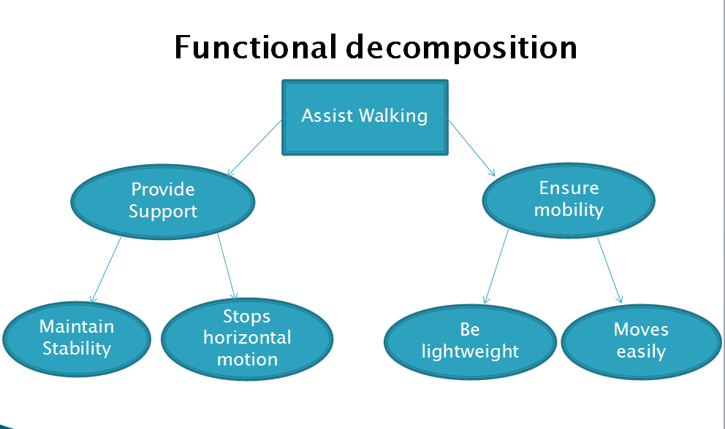

Figure 38

## A.2: Quality Function Deployment (QFD)

## E:\qfd pic.png

Figure 39

## A.3: Pugh Decision Matrix

A Pugh Matrix was constructed to enable us to make a more objective choice on which design to adapt for our walker. Three different designs were weighed according to the criteria listed below.

The first was a suspension mechanism not unlike the conventional ones that can be found on bikes and cars. The second was a retractable pen mechanism that uses a cam and ratchet to either engage or disengage the brakes. The hand triggered brake mechanism is the one that can be found on walkers in the market currently. We considered making minor modifications to it to make it more effective in stopping a user from slipping and falling.

As can be seen, the hand triggered mechanism was used as the datum as it was thought to be the best device as it is the current standard bearer when it comes to walkers.

|  |  |  |  |
| --- | --- | --- | --- |
|  | Suspension Mechanism | Retractable Pen Mechanism | Hand Triggered Brake Mechanism (Datum) |
| Stops horizontal motion | -1 | 0 | 0 |
| Stops vertical motion | 1 | 1 | 0 |
| Can remain locked | -1 | 0 | 0 |
| Overall reliability | 0 | 1 | 0 |
| Cost | 1 | 0 | 0 |
| Safety | -1 | 1 | 0 |
| **Total** | **-1** | **3** | **0** |

*Table 3: Shows the first Pugh Decision Matrix iteration for the three designs.*

After the first iteration, it became obvious that the retractable pen mechanism had some very obvious advantages when it came to retarding the potential fall of the user. Since it raked in the most points in the first iteration, it was chosen as the datum for the second one.

|  |  |  |  |
| --- | --- | --- | --- |
|  | Suspension Mechanism | Retractable Pen Mechanism (Datum) | Hand Triggered Brake Mechanism |
| Stops horizontal motion | -1 | 0 | 0 |
| Stops vertical motion | 0 | 0 | -1 |
| Can remain locked | -1 | 0 | 0 |
| Overall reliability | -1 | 0 | 0 |
| Cost | 1 | 0 | 0 |
| Safety | -1 | 0 | 0 |
| **Total** | **-3** | **0** | **-1** |

*Table 4: Shows the second Pugh Decision Matrix iteration for the three designs.*

From the matrix, it is again obvious that the best overall design is that of the retractable pen mechanism. Hence, it was chosen as the mechanism of choice.

## A.4: Failure Mode and Effects Analysis



*Table 5: Shows the FMEA analysis for the walker device.*

# Appendix B

## Bill of Materials

The bill of materials was done in two portions. The first, for the cam-ratchet mechanism and the second for the walker frame.

|  |  |  |  |  |  |  |
| --- | --- | --- | --- | --- | --- | --- |
| Part No. | Name | Quantity | Description | Supplier | Price Per | Cost |
| 1 | Threaded-Stem Casters | 4 | Dia = 6” | McMaster | $ 21.51 | $ 86.04 |
|  | -Carr |
| Easy-roll &Shock-Absorbing Rubber |  |
|  |  |
|  |  |
| 2 | Slide-On Round Grip | 2 | Standard | McMaster | $ 5.66 | $ 11.32 |
|  |
| -Carr |
| 3 | Aluminum Rod | 2 | OD=1” | McMaster | $ 19.34 | $ 38.68 |
| Length =3 ft | -Carr |
|  |  |
| 4 | Aluminum Round Tube (A) | 1 | OD=5/8” | McMaster | $ 22.47 | $ 22.47 |
| Length=3 ft | -Carr |
|  |  |
| 5 | Aluminum Round Tube (B) | 1 | D=1/2” | McMaster | $ 19.35 | $ 19.35 |
| ID = 0.37” | -Carr |
| Length = 3 ft |  |
| 6 | Aluminum Rectangular Bar | 1 | Thick = 5/16” | McMaster | $ 7.89 | $ 7.89 |
| Wd = 3” | -Carr |
| Length = 1 ft |  |
| 7 | Stainless Steel Shoulder Screws | 2 | Shoulder Length = 1” | McMaster | $ 6.66 | $ 13.32 |
| Shoulder D =0.5” | -Carr |
| Thread Size = 3/8” 16 |  |
| 8 | Hex Nut (100pack) | 1 | Thread Size = | McMaster | $ 6.51 | $ 6.51 |
| 3/8” 16 | -Carr |
| 9 | Basket (Optional) | 1 |  | Amazon | $ 15.00 | $ 15.00 |
| 10 | Strap | 1 | Length=80cm | Alibaba | $ 2.00 | $ 2.00 |
|  |  |  |  |  |  |  |
|  |  |  |  |  | Subtotal | $ 222.58 |

And for the cam-ratchet mechanism,

|  |  |  |  |  |  |  |
| --- | --- | --- | --- | --- | --- | --- |
| Part No. | Name | Description | Quantity | Supplier | Cost per Unit | Total Cost |
| 1 | Large Bearing Flange | 1" ID, Polyester | 1 | QBC Inc | $ 0.76 | $ 0.76 |
| 2 | Small Bearing Flange | 1/2" ID, Polyester | 1 | QBC Inc | $ 0.96 | $ 0.96 |
| 3 | End Cap | 2" Nominal. Galvanized | 2 | Global Industrial | $ 7.75 | $ 15.50 |
| 4 | Tube | 2" Schedule 40, 4" L, A304 SS | 1 | Global Industrial | $ 7.75 | $ 7.75 |
| 5 | Shaft | 1/2" ID, 4" L, A304 SS, Smooth Finish | 1 | Ace Stainless Supply | $ 2.82 | $ 2.82 |
| 6 | Clamp | 1/2" ID, 13/32" L, Steel | 1 | Global Industrial | $ 1.10 | $ 1.10 |
| 7 | Magnet | 1/2" ID, 1.75" OD, 1/2" L, N42 | 1 | K&J Magnetics | $ 23.30 | $ 23.30 |
| 8 | Axial Bearing | 1" ID, 1.8" OD, 0.125 L, PTFE | 1 | Boker's Inc | $ 2.30 | $ 2.30 |
| 9 | Spring | 1.5" OD, 0.091 wire D, 2.63" L, Stainless | 1 | Century Spring | $ 7.85 | $ 7.85 |
| 10 | Ratchet | ABS, Refer to drawing | 1 |  | $ 0.08 | $ 0.08 |
| 11 | Cam | ABS, Refer to drawing | 1 |  | $ 0.05 | $ 0.05 |
| 12 | Follower | ABS, Refer to drawing | 1 |  | $ 0.23 | $ 0.23 |
|  |  |  |  |  |  |  |
|  |  |  |  |  |  |  |
|  |  |  |  | Subtotal |  | $ 62.70 |

# Appendix C

## Manufacturing Costs Estimate

### Cam-Ratchet Mechanism

|  |  |  |  |  |  |  |
| --- | --- | --- | --- | --- | --- | --- |
| Part No. | Name | Description | Quantity | Supplier | Cost per Unit | Total Cost |
| 1 | Large Bearing Flange | 1" ID, Polyester | 1 | QBC Inc | $ 0.76 | $ 0.76 |
| 2 | Small Bearing Flange | 1/2" ID, Polyester | 1 | QBC Inc | $ 0.96 | $ 0.96 |
| 3 | End Cap | 2" Nominal. Galvanized | 2 | Global Industrial | $ 7.75 | $ 15.50 |
| 4 | Tube | 2" Schedule 40, 4" L, A304 SS | 1 | Global Industrial | $ 7.75 | $ 7.75 |
| 5 | Shaft | 1/2" ID, 4" L, A304 SS, Smooth Finish | 1 | Ace Stainless Supply | $ 2.82 | $ 2.82 |
| 6 | Clamp | 1/2" ID, 13/32" L, Steel | 1 | Global Industrial | $ 1.10 | $ 1.10 |
| 7 | Magnet | 1/2" ID, 1.75" OD, 1/2" L, N42 | 1 | K&J Magnetics | $ 3.30 | $ 23.30 |
| 8 | Axial Bearing | 1" ID, 1.8" OD, 0.125 L, PTFE | 1 | Boker's Inc | $ 2.30 | $ 2.30 |
| 9 | Spring | 1.5" OD, 0.091 wire D, 2.63" L, Stainless | 1 | Century Spring | $ 7.85 | $ 7.85 |
| 10 | Ratchet | ABS, Refer to drawing | 1 |  | $ 0.08 | $ 0.08 |
| 11 | Cam | ABS, Refer to drawing | 1 |  | $ 0.05 | $ 0.05 |
| 12 | Follower | ABS, Refer to drawing | 1 |  | $ 0.23 | $ 0.23 |
|  |  |  |  |  |  |  |
|  |  |  |  |  | Subtotal | $ 9.07 |

|  |  |  |  |  |  |
| --- | --- | --- | --- | --- | --- |
| Process # | Part/Assy. Name | Process | Quantity | Unit | Cost |
| 1 | Bottom Bracket | Setup/Removal | 4 | unit | $2.60 |
| 2 | Machining-Waterjet | 44 | inch | $0.44 |
| 3 | Base | Setup/Removal | 6 | unit | $3.90 |
| 4 | Cut to Length | 2 | unit | $0.30 |
| 5 | Drill Holes | 2 | unit | $1.00 |
| 6 | Mandrel Bend | 2 | unit | $1.50 |
| 7 | Tube Welding Prep | 1 | unit | $0.75 |
| 8 | Weld Tubes | 3.7 | inch | $0.56 |
| 9 | Weld Bracket | 5 | inch | $ 0.75 |
| 10 | Weld Joints | 6 | inch | $0.90 |
| 11 | Insert Casters | 4 | unit | $2.00 |
| 12 | Install Brake Pads | 4 | unit | $3.00 |
| 13 | Setup Change | 7 | unit | $4.55 |
| 15 | Arc Tube | Setup/Removal | 8 | unit | $5.20 |
| 16 | Drill Holes | 15 | unit | $5.25 |
| 17 | Machining-Grind | 1.23 | Square Inches | $1.20 |
| 18 | Mandrel Bend | 4 | unit | $3.00 |
| 19 | Weld Bar to Tubes | 1 | inch | $0.25 |
| 20 | Setup-Change | 12 | unit | $7.80 |
| 21 | Walker | Setup/Removal | 1 | unit | $1.00 |
| 22 | Connect Arc Tube to Base | 2 | unit | $1.60 |
| 23 | Connect R-C Mechanism to Base | 2 | unit | $1.60 |
| 24 | Connect R-C Mechanism to Arc | 2 | unit | $1.00 |
| 25 | Insert Handles | 2 | unit | $1.00 |
| 26 | Test Assembly | 1 | unit | $ 0.50 |
| 27 | Adjustments-Misc | 1 | unit | $5.00 |
|  |  |  |  | Subtotal | $ 56.65 |

### Walker

Appendix D

Drawings

Appendix E

Product Specifications