Mobility-Enhancing Fall-Prevention Device for Physical Rehabilitation

Carl A. Nelson¹, Judith M. Burnfield², Linxia Gu¹

¹Department of Mechanical & Materials Engineering,
University of Nebraska-Lincoln
²Institute for Rehabilitation Science and Engineering, Madonna Rehabilitation Hospital

1 Background
Maintaining personal mobility is a critical component of health and well-being for the elderly as well as those recovering from debilitating injuries or illnesses. Regular physical activity can help prevent bone loss and generally maintain the musculoskeletal system as well as cardiovascular health. Following a serious injury, illness, or major surgery many individuals may need to use a walker to ensure safe and pain-free mobility. However, poor balance or movement control problems can make it difficult to safely use a walker, particularly on sloped surfaces. In this paper a special type of walker is presented for helping enhance stability and maintain a healthy lifestyle.
This new walker is intended to improve the primary functionality of reducing fall risk, through implementation of a passively triggered braking system. The load-based trigger is designed to be adjustable such that individuals of varying weights can successfully use the walker. It is anticipated that this will allow users to become more confident while using their walker and enjoy a better quality of life.

2 Methods
The load-triggered locking walker was designed to provide a more stable protection against falls compared to existing walkers. There are two major design elements that need to be addressed in a walker: the need for mobility and the need for an effective fall prevention mechanism. The issue to be considered is how to increase one without reducing the other as they tend to be inversely correlated. Wheeled walkers generally provide good mobility but may roll out from under the individual during a fall event, and sliding walkers provide better stability during a fall but are generally more difficult to maneuver due to increased friction. Furthermore, hand brakes may not be effective during a fall event due to the quick application of significant force required to actuate them. The developed device is a wheeled walker with brakes which are passively triggered when an individual applies downward load to the walker above a specified threshold, as might occur during a fall event.
The walker frame was designed to be made from 6061 aluminum tubing similar to existing walker designs (see Figure 1). Its high specific strength makes this material a good choice for a portable mobility device. A combination of bent tubing, welded joints, and pinned joints is used to give the walker its appropriate shape and allow for the device to fold compactly for storage and transport.

The braking mechanism is inspired by retractable ballpoint pens. In this common design, a periodic set of inclined planes is arranged circumferentially on a cam, and a similarly shaped follower rides against the cam. Based on the cam-follower geometry, sequential depressions of the cam produce an alternating locking and unlocking of the axial position of the shaft aligning the cam and follower (see Figure 2). In this case, the shaft is used to depress a drum brake against the wheels to generate a locking behavior. A magnet provides a preload which governs the activation force threshold. The activation force can be adjusted by moving a pin to different hole locations in the handlebar (see Figure 1), which changes the angle and therefore the force transmission through the brake-actuation linkage. Thus, a fall event triggers locking of the brakes, and a subsequent purposefully applied load unlocks the brakes.
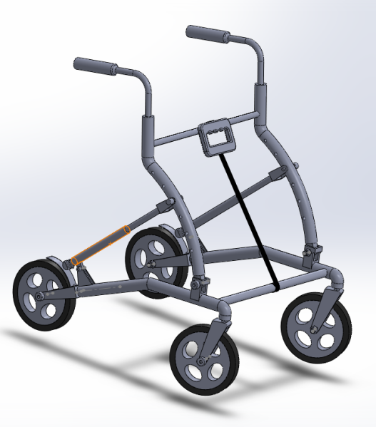
Figure 1. Load-triggered locking walker for improved mobility.

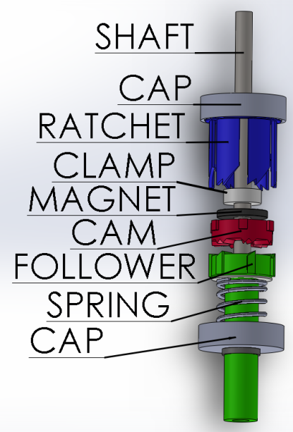
Figure 2. Locking brake assembly.

3 Results
As shown in Figure 3, the adjustable angle of the compression link in the walker frame affects the mechanical advantage in the brake mechanism up to about a factor of 2. This allows the walker to be easily tailored for each individual and his/her load-transfer habits when using the walker. This adjustment feature can also be used therapeutically (e.g., for setting clinical goals with respect to decreased load bearing on the walker).
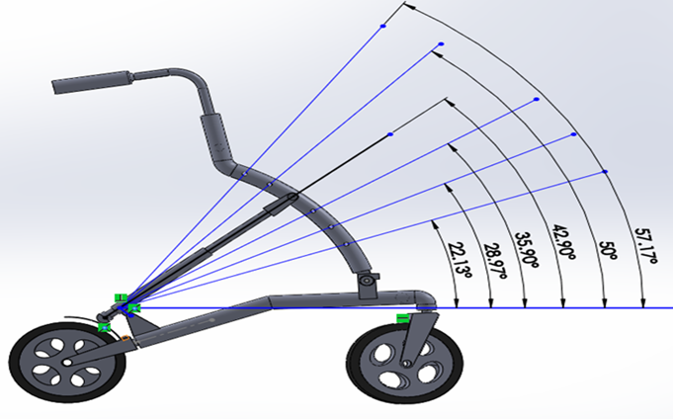
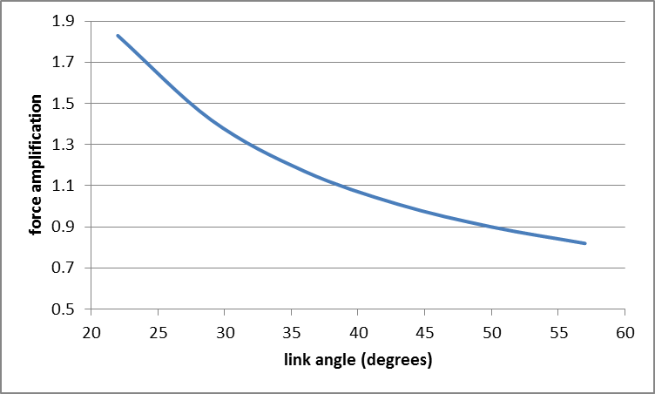
Figure 3. Angular dependence on force transmission (load threshold for locking adjustment).

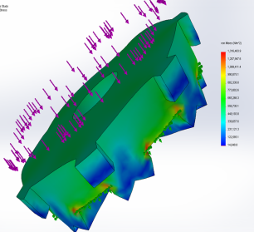 | 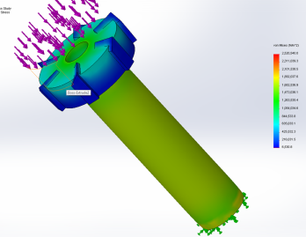
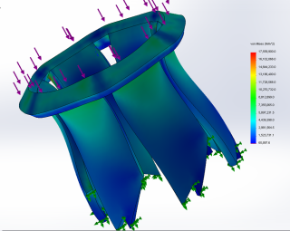
Figure 4. FEA of the critical points of stress in the braking mechanism.
Extensive finite element analysis was carried out to determine how loads would be distributed through the system. Based on an applied vertical load of 1340 N (300 lbs) on the handlebars, the smallest safety factor had a value of 1.7. The most critical components are the ABS plastic parts in the ratcheting mechanism (cam, ratchet, and follower) housed in the leg of the walker; the stress distributions are shown in Figure 4.

4 Interpretation
The load-triggered locking walker allows increased stability and mobility for individuals with gait impairment due to age, injury, or disease. This can help improve general health by encouraging physical activity and removing obstacles to activities of daily living. Stress analysis shows that persons up to 150 kg can safely use the device, and the design allows for adjustability to adapt the braking load threshold for lighter individuals according to personal preference. Future work includes comparative testing of the device with healthy and impaired subjects across a range of body types.

Acknowledgement
The authors wish to acknowledge support from NSF grant 1159626 and the contributions of W. Dick, M. V. Rao, K. Kathirasen, L. Kong, and D. Zhang to the design work.

References
References follow ASME style, described in See the “Writing a Technical Paper or Brief” section, under Guidelines at the ASME Journal Tool Author Help (http://tinyurl.com/43chze9)

