Executive Summary

This report provides a fairly detailed breakdown of the synthesis and analysis of a catapult design. It started with a ballistic analysis which indicated the amount of energy needed to throw the projectile the specified distance. Four extension springs were used to provide in excess of 7500 J of energy which is more than sufficient to animate the shaft and the launching beam while also hurling the projectile at least a 100 m. A gear system was used to greatly decrease the amount of force the user has to exert to lock the catapult in firing position. Another advantage of having the gear system is it adds versatility to the catapult as it would also be able to hurl the projectile to any specified distance under a 100 m. This can be achieved by not loading the spring until it reaches its maximum deflection. The catapult will have castors at the base which would greatly enhance its mobility while their four rubber tires would act as a basic suspension system. Two major considerations were kept in mind throughout the design process: to make it as lightweight and cost-effective as possible. The cost of the final product is $ 4526.20 and the total weight is 1182 kg. Illustrations of the critical components along with their dimensions can be found in the appendix.

Problem Statement

The stated aim of this project is to build a catapult that is capable of throwing a 3-kg projectile 100 meters. All the components should be made sure to have a safety factor of two. The catapult should be designed with portability, cost and weight being of prime importance.

Design Approach

Before the first group meeting, each of us took some time to do some basic calculations regarding the minimum energy requirement for the catapult. With the results in hand, we brainstormed about the design of our catapult. We had a few designs in mind; the major difference between them being the kind of spring (compression, extension or torsion) that would be used to launch the projectile. After due thought, we settled on an extension spring so as to stay as faithful as possible to the traditional conception of a medieval catapult. We then proceeded to calculate the spring specifications that were needed while concurrently calculating the shaft and launching beam’s dimensions and weight requirements.

One of most crucial things that we had in mind throughout the design process was to make the mechanism as reliable and user-friendly as possible; hence we minimized the number of components needed to operate it. Another design consideration was to make it as lightweight and cost-effective as possible.

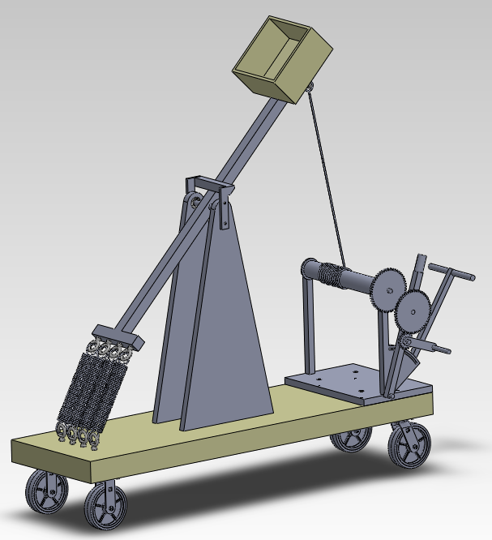
Figure 1: Shows a Solid Works drawing of the finished catapult

Analysis

Ballistics / Energy Analysis:

The first assumption that was made was that the air friction is negligible (zero). The second was that the projectile is spherical in shape. This is as the problem statement did not specify a particular dimensional requirement for the projectile. The energy requirements were calculated based on this.

The trajectory calculations were fairly straightforward. The range was taken from the problem statement that specified that the projectile be thrown a 100m. Then, the range formula (below) was used to calculate the launch velocity of the projectile and the optimal angle of launch.

$R=\frac{V_{0}\sin\left(2θ\right)}{g}$………. (1)

where R = range; V₀ = launch velocity; θ = angle of launch; and g = gravitational constant.

However, this formula has two variables that need to be computed for. Therefore, the range was differentiated with respect to θ. The equation that resulted is shown below.

$\frac{dx}{dθ}=\frac{2vo^{2}}{g}\cos\left(2θ\right)= 0$………. (2)

The optimum launch angle was found to be 45º. The velocity was then found to be 31.32 m/s. the next step was to find the amount of energy needed to launch a 3kg projectile at the found velocity. The equation used is shown below.

$E= 0.5 mv^{2}$………. (3)

where E = Energy; m = mass; v = velocity

When the mass and velocity values are inserted in the equation, the energy needed is found to be 1469.54 J. This of course only takes into consideration the energy required to launch the projectile and not to animate the other components.

The energy analysis above formed the basis of the catapult design and was used to calculate the requirements for the other mechanisms.

Component Analysis:

Spring

The spring was the first component that was considered during the first stage of the process due to its importance. The first step was to decide on the type of spring and the spring material. An extension spring made of Hard-Drawn Wire, ASTM No. A227 was chosen. The rationale behind the material selection is its cost efficiency and the fact that it satisfies the tensile and yield strength requirements.

To obtain the best spring specifications possible, we created a list of the most important characteristics that the spring should possess. The list is as follow:

- Has a minimum safety factor (n) of 1.2
- Provides sufficient energy to launch the projectile
- Falls in the C = 4 to C = 12 range
- Has the fewest number of active coils
- Has a reasonable deflection length

With these requirements in mind, all the variables were tabulated in Microsoft Excel to obtain the best spring possible or at least one that satisfies all the above requirements. The data matrix was tabulated according to the range of C values that was allowable. According to Shigley’s Mechanical Engineering Design textbook, the allowable range is C = 4 till C = 12. The C value denotes the coil diameter (D) divided by the wire diameter (d). The calculations that were performed are as follow. The first was to calculate the tensile strength of the H-D Wire. This was done using Equation 4:

$S_{ut}=\frac{A}{d^{m}}$………. (4)

where S_{ut} = tensile strength; A = intercept (constant) ; m = slope (constant)

The yield strength was then calculated using Equation 5:

$S_{sy}=0.45S_{ut}$………. (5)

where S_{sy} = yield strength

Next, the Shear Stress Correction Factor was calculated:

$K_{B}= \frac{2C+1}{2C}$………. (6)

With these values in hand, the force (F) that the spring exerts was found using the Equation 7

$F= \frac{πd^{3}S_{sy}}{8K_{B}D}$………. (7)

and the spring constant (k) was calculated using Equation 8.

$k= \frac{d^{4}G}{8D^{3}N_{a}}$………. (8)

The spring deflection (x) was then calculated followed by the energy $(E_{s})$ stored in the spring.

$x=\frac{8FD^{3}N}{d^{4}G}$.......... (9)

$E_{s}=\frac{1}{2}Kx^{2}$……….. (10)

where G is a constant provided in Table 10-5 of Shigley’s textbook.

When all these data was tabulated, a problem was encountered. To meet the energy requirement, the spring deflection had to be really long and this means very long springs would be needed. Increasing the length of the spring would mean building a much bigger catapult with a longer beam and shaft. This was undesirable as it would drive up the cost and would add unneeded bulk. To counter this problem, four springs were used. This reduced the amount of deflection required for one spring while also satisfying the energy requirement.

The table below shows the specifications of the chosen spring. This spring met all the requirements stated above.

Spring Constant k, (N/m) | d (m) | D (m) | G (GPa) | F (N) | C
3264.119601 | 0.0049 | 0.0539 | 78600000000 | 903.5471 | 11

Number of Active Coils, N_{a} | Safety Factor, n | Deflection Length, x (m) | E (Pa) | K(s)
43 | 2 | 1.074159277 | 80973.31 | 1.045455

S(ut), (Pa) | S(sy), (Pa) | Energy (J)
4897947074 | 2204076183 | 1883.1

Table 1: Shows the spring specifications (for one spring).

Since an extension spring was chosen, some additional calculations were needed. This was to account for the loop on either end of the spring. The safety factor for point A and point B should be checked so that it does not fall below n = 1.2.

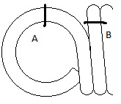
Figure 2: An illustration of an extension spring’s end loop. At point A, the spring undergoes maximum tensile strength and at point B, it undergoes maximum torsional stress.

A full twisted loop was chosen as the preferred design for the spring as this would ensure the spring doesn’t slip off the hooks on the beam or the base. The maximum tensile stress at A and the maximum torsional stress at B was calculated using:

$σ_{A}=F\left[{(K)}_{A}\frac{16D}{πd^{3}} + \frac{4}{πd^{2}} \right]$………. (11)

$τ_{B}= {(K)}_{B}\frac{8FD}{πd^{3}}$………. (12)

where (K)_{A} = bending stress correction factor; (K)_{B} = stress correction factor for curvature; F = force applied

The safety factor (n) for point A and point B can be found using:

$n_{A}= \frac{S_{y}}{σ_{A}}$ ………. (13)

$n_{B}= \frac{{{(S}_{sy})}_{B}}{τ_{B}}$………. (14)

n_{A} was found to be 1.60 and n_{B} was 13.42. This indicates that the spring has enough strength and will be able to withstand the force exerted.

Shaft and Beam:

The shaft along with the spring forms the most critical components of the catapult. The shaft was designed to be as short as possible so as to minimize the cost as well as to reduce the moment acting on it. One unique attribute of the shaft design is that the shaft and the beam were custom-made to be connected to each other perpendicularly. This made sure that the problem of bolting or welding it would not arise and greatly lowered the risk of fatigue failure.

The shaft dimensioning was done according to the spring constant which was 3264.12 Nm. The shaft has the dimensions 0.203 m and a diameter of 0.025 m. The value of the spring constant was multiplied by the number of springs installed (4) and the maximum deflection of a single spring. This provided the total force that acts on the beam due to the spring, which equals 14,027.88 N. There is a stress concentration factor at the bottom of the connection between the shaft and the beam. The bending moment at this point was calculated using the formula:

$M=F*distance=14027.88 N*0.0762 m=1069 N. m$ ………. (15)

The bending moment diagram of the shaft is shown in the diagram below.

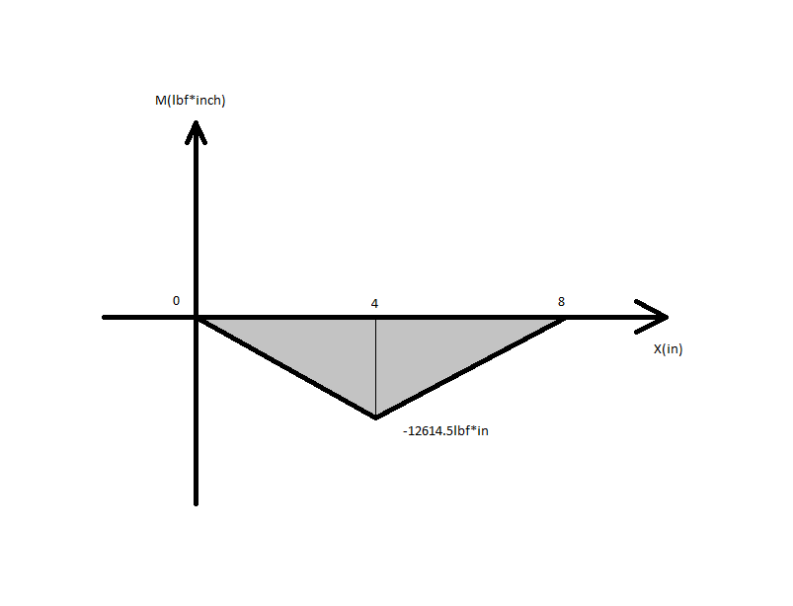
Figure 3: Shows a bending moment diagram of the shaft

The stress at this point can then be calculated using the formula:

$σ=32*\frac{M}{π*d^{3}}=32*9461.45*\frac{\frac{32}{π}}{1^{3}}=96.4kpsi=664.65 Mpa$ ………. (16)
To ensure a safety factor of 2, the yield strength of the shaft was made sure to be at least 664.65 Mpa.
The beam has the dimensions $0.0508 m×0.0508 m ×1.500 m$ and the moment I equals to$0.0508 m ×{0.0508 }^{3}m=6.66 ×{10}^{-6} m^{4}$. When the spring is fully extended, the mid-point of the beam will suffer the maximum amount of bending stress and shear stress. The bending stress can be calculated using the equation:

$σ=\frac{Mc}{I}=93117.9*\frac{1}{\frac{4}{3}}=69.84kpsi=481.59 MPa$………. (17)

While the shear stress at the mid-point was calculated using the equation:

$τ=\frac{3V}{2A}=3*\frac{3153.47}{2*4}=1.2kpsi=8.27 MPa$………. (18)

And:

$σ`={\left(σ^{2}+3*τ^{2}\right)}^{0.5}=70kpsi=482.63 MPa$ ………. (19)

To ensure a safety factor of 2, the yield strength was made sure to be at least 966 MPa. The yield strength of the AISI 4130 steel used is 1460 MPa which means the component has a safety factor of 3.03.

Bearings:

Since the launching beam sits right in the middle of the shaft, the weight that is exerted on it is evenly spread out to both the bearings that support it on both ends of the shaft. So, the force of 27,602.4 N is divided evenly and so 13,801.3 N acts on one bearing. Besides, only a radial load acts on the bearing and since there is an absence of thrust load, the bearing that solely takes radial load can be chosen. To look for a suitable bearing, McMaster-Carr’s catalogue was referred to. The bearing that was found most suitable was bearing no. 22205. This particular bearing was chosen due to its high C₁₀ value of 37498.5 N and its’ favorable inside diameter of 24 mm. This gives the bearing a safety factor of 2.72 which is more than satisfactory.

Following this, the life cycle of the bearings was determined using the equation below:

$C_{10}=F_{D}\frac{L_{D}n_{D}60}{{10}^{6}}$………. (20)

The life (L_{D}) value was determined to be 3942 hours which means the catapult is long lasting.

Gears:

Four gears were added to the catapult after it was found that no single individual could pull the catapult back to launching position. It required 14,028N and to reduce this, gears with varying teeth count were installed. For this application, the rate-per-minute (rpm) is low so limit on the amount of force it can withstand is high. Four gears were used to form a gear train and function to step down the amount of force needed. Two G3-17 gears and two G3-51 gears from HPC Gears were used. They have a 1:3 teeth ratio and reduce the total force needed to one ninth its original number. A graphical representation of the gear train is provided below, in Figure 4.

Gear A
D = 151MM

The first gear mate
Gear B
D = 51MM

Gear C
D = 151MM

The second gear mate
Gear D
D = 51MM

Figure 4: Shows an illustration of the gear train

The torque equation for the first gear is as below:

$T_{1}=F*\frac{d}{2}=14027.88*1.5*\frac{2.54}{100}=534.5N∙m$ ………. (21)

Then the tangential force transfers to the second gear:
$T2=Ft1*r2=7079.5*0.0255=180.53N∙m$ ………. (22)
$Ft3=\frac{T2}{r3}=\frac{180.53}{0.0755}=2391.13N$ ………. (22)
$T4=Ft3*r4=2391.13*0.0255=60.97 N∙m$ ………. (23)
where Ft = tangential force and T = Torque

Non-Critical Components

Crank:

The crank is connected to the crankshaft which in turn is connected to Gear 4. The amount of force that the person needs to apply can be calculated using the equation:

$F= \frac{T}{d}=334.3 N$ ………. (24)

As can be seen, the force of 334.3 N is easily applied by an average human. This means locking the catapult in firing position should not be a problem.

Cable:

The amount of force that will be applied on the cable is basically the amount of force that will be exerted by the spring on the beam. This equals to 3620 N. So, a 1 × 19 cable was selected from McMaster-Carr which had more than double the breaking strength. This ensured that the cable had a safety factor of 2.

Special Mention: How the gear mechanism works

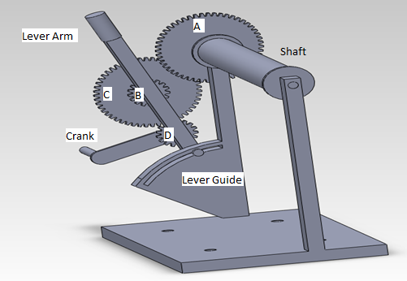
Figure 5: Shows a Solid Works drawing of the gear mechanism

As can be seen in the figure above, there are two large gears of equal size and two small gears of equal size. The crank will be rotated and this would rotate the shaft which in turn pulls the cable in, which locks the catapult in firing position. When the projectile is to be released, the lever arm will be pulled down from its initial position. This would result in Gear B losing contact with Gear A. The immense force of the spring on the beam would then unwind the cable and fire the projectile.

Cost Analysis

The prices of all the parts of the catapult were added together. The cost breakdown is detailed in the Bill of Materials. The assembly of the parts was estimated to be $400 according to the assembly calculation that was provided. The grand total was calculated to be $ 4526.20.

Design Summary

The design of this catapult is based on the problem statement that says it should be able to launch a 3kg projectile that can travel 100 m. Based on this broad requirement, a design was conceived through multiple discussions and meetings. The energy analysis that was done became the basis of the design. The first things decided were the type of spring to use and its material. Then the spring’s dimensions and specifications were calculated while concurrently calculating the dimensions and specifications of the launching beam and shaft. These three are interdependent and can’t be designed as separate entities without taking the others into consideration. Then a bearing was chosen based on the force and dimensional requirements.

Then the gear that acts as a pulley was designed keeping in mind that one person should be able to operate it. This is the rationale behind having 4 gears which functions to reduce the amount of human force needed to lock the catapult in position. An appropriate cable was chosen based on its ability to withstand the force that needs to be applied to lock it. Then, the castors were added to it. However, this design is not market ready as some details about the non-critical components were left out of the design analysis.

Conclusion

The design requirements were religiously followed and the design that we had in mind was successfully implemented. The calculations are solid and some additional extra features were added to make the catapult more appealing to the market.

References

Budynas, Richard G., J. Keith. Nisbett, and Joseph Edward. Shigley. Shigley’s Mechanical Engineering Design. Boston: McGraw-Hill, 2009. Print

Appendix

Bill of Materials

Item Name | Item Number | Quantity | Part Number | Material | Source | *Estimated Cost($)
Extension Spring | 1 | 4 | Customized | H-D Wire AISI 1066 | Marni Spring Corp. | 855.00
Bearing | 2 | 2 | 2721T1 | Stainless steel | McMaster-Carr | 153.58
Shaft and beam | 3 | 1 | Customized | AISI 4130 Steel | Alibaba** | 300
Spur Gear Type 1 | 4 | 2 | G3-17 | Steel 214M15 | HPC Gears | 64.71
Spur Gear Type 2 | 5 | 2 | G3-51 | Steel 214M15 | HPC Gears | 244.58
Crank | 6 | 1 | Customized | AISI 4130 Steel | Alibaba | 6
Crank Shaft | 7 | 1 | Customized | AISI 4130 Steel | Alibaba | 20.70
Lever Arm | 8 | 1 | Customized | AISI 4130 Steel | Alibaba | 22.65
Lever Guide | 9 | 1 | Customized | AISI 4130 Steel | Alibaba | 55.32
Cable | 10 | 1.83 m | 3458T94 | Type 302 Stainless Steel | McMaster-Carr | 25.14
Projectile Compartment | 11 | 1 | Customized | Plywood | ACE Hardware | 77.40
Socket Head Cap Screw 1 | 12 | 8 (pack of 50) | 91251A539 | Black-Oxide Alloy Steel | McMaster-Carr | 6.85
Socket Head Cap Screw 2 | 13 | 4 (pack of 5) | 90128A844 | Zinc-Plated Alloy Steel | McMaster-Carr | 6.16
Eyebolt | 14 | 5 | 3049T93 | High Strength Alloy Steel | McMaster-Carr | 131.3
Handlebar | 15 | 1 | Customized | AISI 4130 Steel | Alibaba | 90.63
Swivel Caster with lock | 16 | 2 | 2531T28 | Polyurethane, steel, zinc | McMaster-Carr | 136.70
Rigid Caster with lock | 17 | 2 | 2531T38 | Polyurethane, steel, zinc | McMaster-Carr | 129.16
Socket Head Cap Screw 3 | 18 | 12 (pack of 25) | 91251A624 | Black-Oxide Alloy Steel | McMaster-Carr | 6.46
Base | 19 | 1 | Customized | Construction Wood | Alibaba | 600
Posts | 20 | 2 | Customized | AISI 4130 Steel | Alibaba | 795.18
Stopper | 21 | 1 | Customized | AISI 4130 Steel | Alibaba | 76.44
Steel Rod | 22 | 1 | Customized | AISI 4130 Steel | Alibaba | 192.71
Brackets | 23 | 8 | 15655A21 | Type 304 Stainless Steel | McMaster-Carr | 124.40
Nails | 24 | Pack of 100 | 97801A501 | Stainless Steel | McMaster-Carr | 5.13

* The estimated cost can and most likely will vary from manufacturer to manufacturer and only functions to provide a rough estimate of the costs.
** All the cost estimates from Alibaba.com were calculated by obtaining the price per ton of the material and multiplying it by the weight of the part being made. This took into account the fact that machining a part would result in the part costing three times the original price.

Total cost of all the parts: $4126.20

Total cost of the catapult (including assembly): $4526.20

